UNIVERSITY OF BALOCHISTAN

QUETTA

DEPARTMENT OF COMPUTER SCIENCE AND INFORMATION TECHNOLOGY

<

**DATABASE SYSTEM**

DR. Abdul Basit Khan

Project:

**CS DEPARTMENT MANAGEMENT SYSTEM**

SUBMITTED BY: MUHAMMAD MURAD

ROLL NUMBER: (45) MCS (4th SEMESTER Morning)

SESSION: 2015-2017

**CONTEXT TABLE**

**Chapters -------------------------------------index**

Acknowledgment-------------------------------------------- (1)

Summary------------------------------------------------------ (2)

Introduction--------------------------------------------------- (3)

Scope of Work----------------------------------------------- (4)

Entities ------------------------------------------------------ (5)

Relationship ------------------------------------------------ (6)

Entity Relationship Diagram----------------------------- (7)

Schema diagram------------------------------------------- (8)

Implementation of Project-------------------------------- (9)

Routes--------------------------------------------------------- (10)

Generation of Instructor Model-------------------------- (11)

Generation of Course Model----------------------------- (12)

Generation of Teaches (diamond) Model------------- (13)

Generation of Student Model ---------------------------- (14)

Generation of Takes (diamond) Model----------------- (16)

Generation of Program Mode----------------------------- (17)

Generation of Designation Model------------------------ (18)

**Acknowledgement**

I am thankful to dr. Abdul Basit khan, who has guided me to design CsMc project in a systematic pattern .Cs department management system provides assistance to the instructor, student and the entire records of the relation of instructor with course ,the student take course, different studies programs and different semester of different program finally ,

**Summary**

This report carries information to implement Cs department management system. I used the Entity-Relationship Model to design a database are that will store and organization the department’s data. I have created database using PostgreSQL with some simple data, the system can keep department management, instructor, course, student, program and designation and relationship between them.

**Introduction**

Department management system relates to the life of people of Cs dept. The role of technology clears the entire difficulties faced by instructors and other staff. It takes to the life matter which is related to department of Cs.

**Scope of Work**

The purpose of any new technology is to make people’s life easier. This project is database used to manage the department and allows the administrate to get information about instructors, students, and different programs, Department management system will organize work inside department and proposed system will do the following tasks..

**Entities**

**Instructor**

Instructor is an entity their store all information about instructor name ,address etc.

**Student**

Student is an entity their stores all information about student like name address, etc.

**Course**

course is an entity their stores all information about course like duration, etc.

**Program**

program is a entity their all information store about room program_id ,title semester etc.

**Designation**

Designation is an entity their all information store about designation and about instructors like des_id ,ina_id etc.

**Relationships**

**Instructor and course**

Instructor and course each relationships are many to one .here instructor is primary key and course is foreign key

**Instructor Teaches Course**

**Course and student**

Course and Student each relationships is many to many .here student is primary key and course is foreign key .

**Student Takes Course**

**Student and program**

Student and program each relationship is many too one .here course is primary key and student is foreign key

**Student Has Program**

**Instructor and Designation**

The relationship between Instructor and designation many to one

**Entity Relationship Diagram**

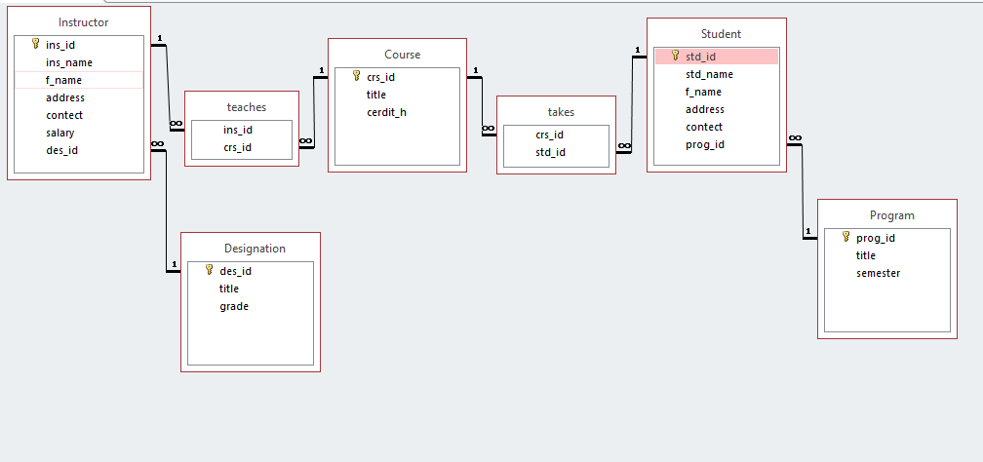

***Schema Diagram***

*Instructor (ins­_id, name, fname, address,contect,salary,desid)*

*Teaches (ins_id, crs_id)*

*Course(crs_id, title,credit_h)*

*Takes(crs_id, std_id)*

*Student(std_id ,name, fname, address, contect ,prog_id)*

*Program(prog_id, title,semester,std_id)*

*Designation(des_id ,title,grade)*

***Implementation of CSMS in ROR***

**Routes**

Routes of the whole project in which we gave resources to the following models in order to get the appropriate controller URL.

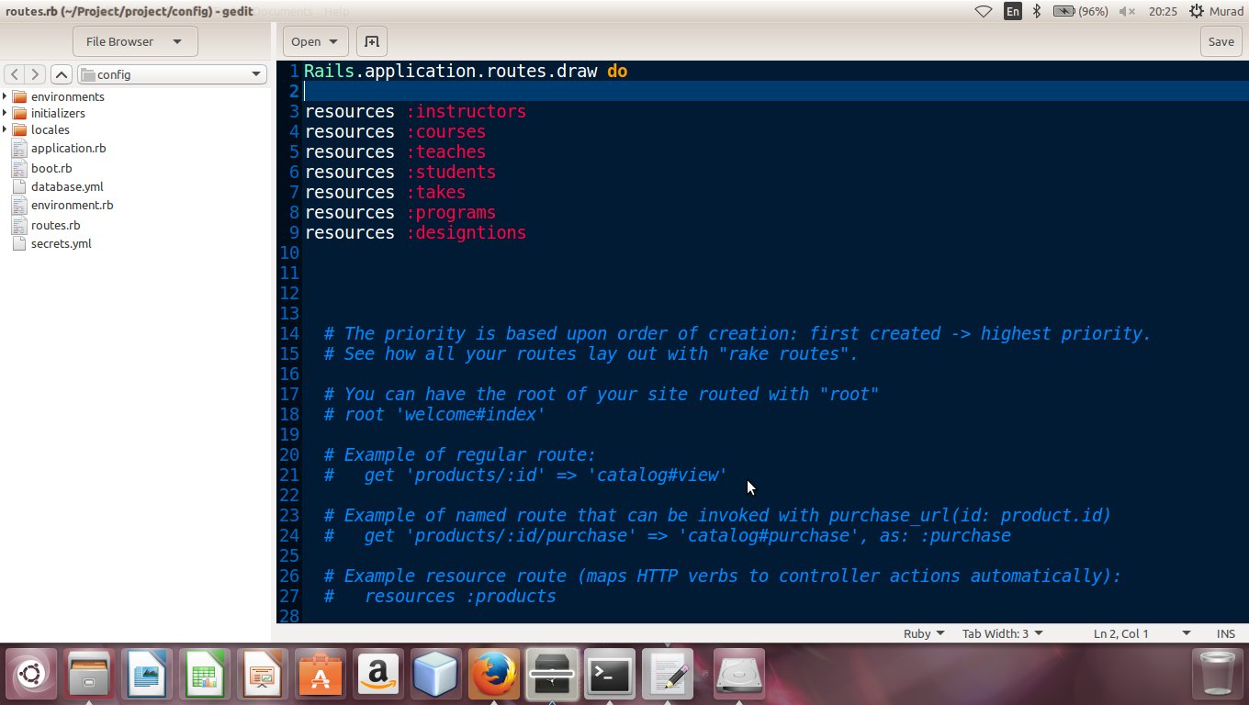

**Generation of instructor controller**

I have generated the instructor Controller in Ruby on Rails and we defined all action of instructions like save the instructor index,delete ,edit ,show and update in controller and controller control all these kinds of action as shown in blow figure.

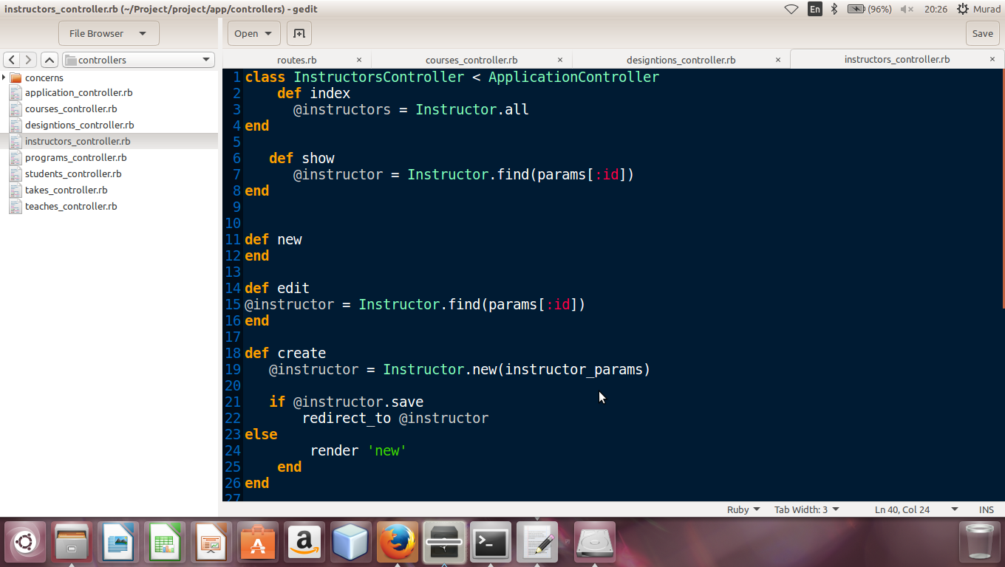

**Generation of Instructor model**

This is Migration file of instructor because we have generated the model of instructor and then we created and migrated its database in ruby on rails

The all attributes of instructor model which we gave with the particular data type while generating instructor model are also shown in migration file of instructor

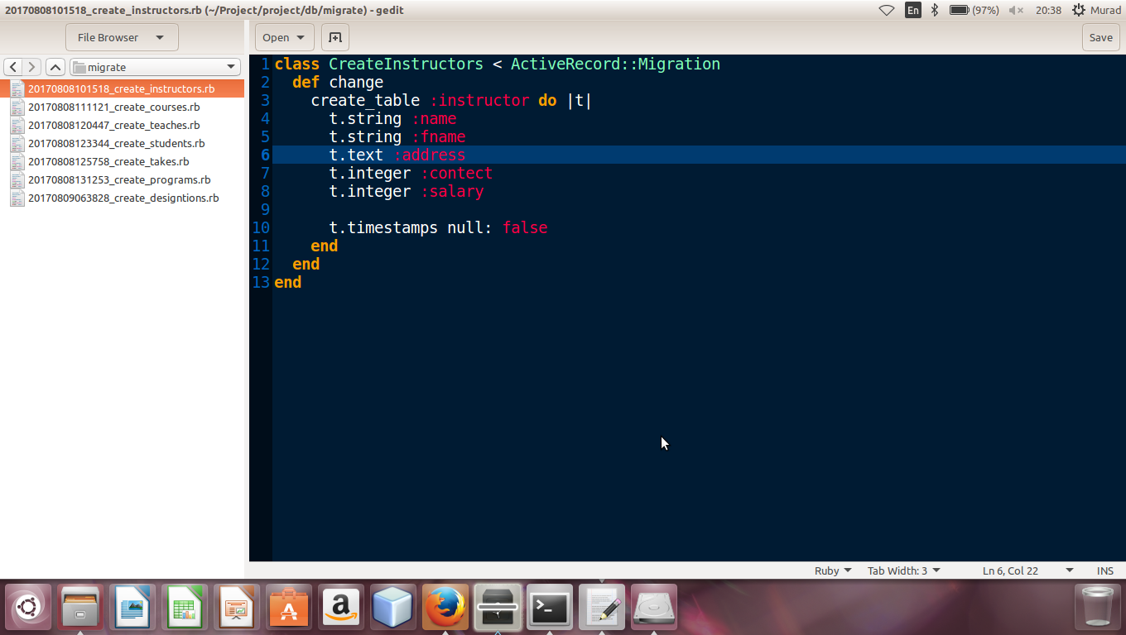

**View of Instructor model**

View folder of contain the following files which are new.html.erb, show.html.erb, edit.html.erb, index.html.erb ,all files are view file for user hand and action are define for these inside controller. the following files are

**now.html.erb**

it contain a form by this we make now entry for instructors

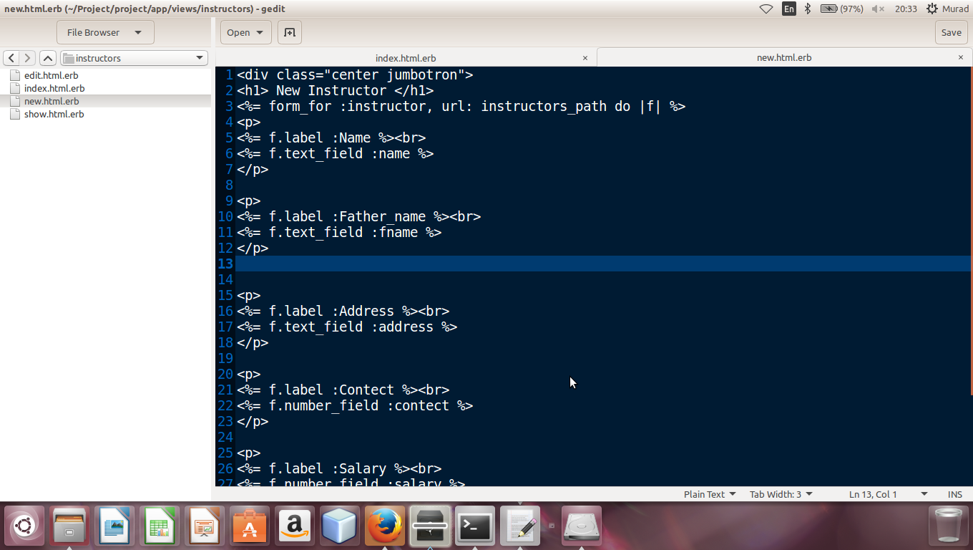

**show.html.erb**

When we put a some in a form of instructor and click on save then show table shows a now enterd form only

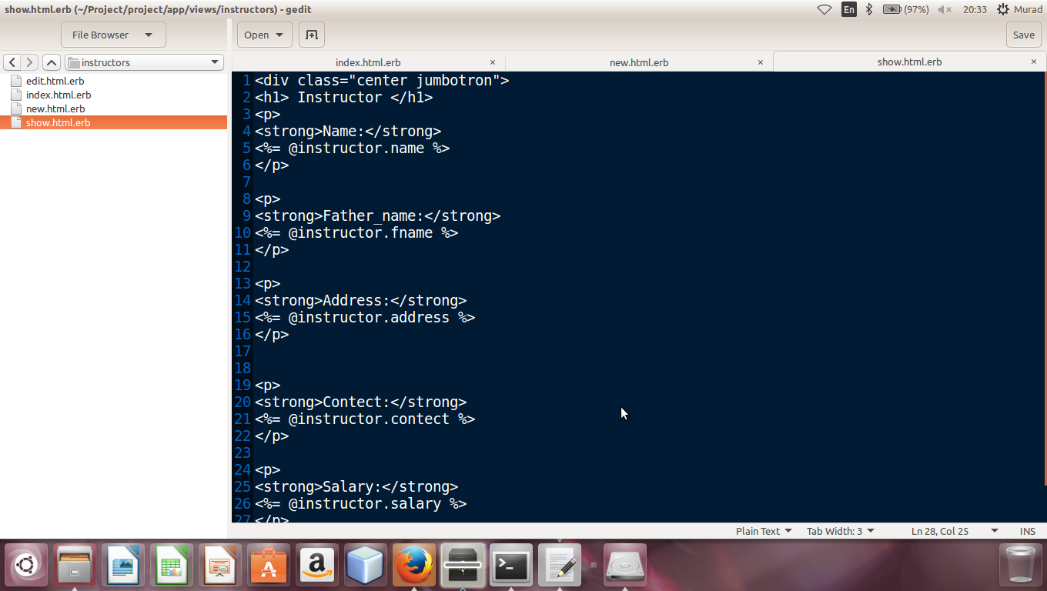

**Index.html.erb**

It contain list of instructors which we entered all instructor are shown in a listing order . it also contain delete ,show and edit option in fornt of each instructor data.

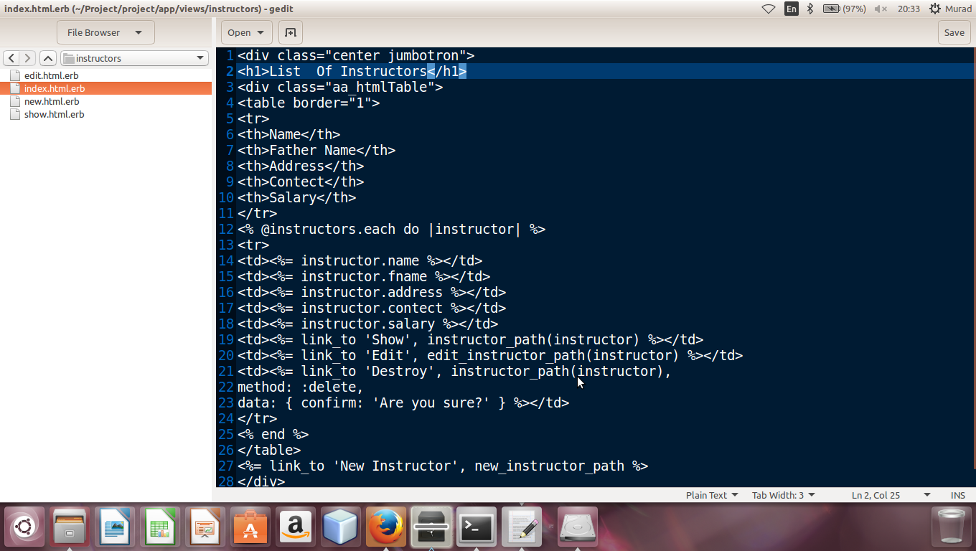

**Model of instructor**

In model of instructor table I showed association of instructor model with others model like instructor model has relation with course through teach and desigantion .Validation on fileds of instructor table are also shown.

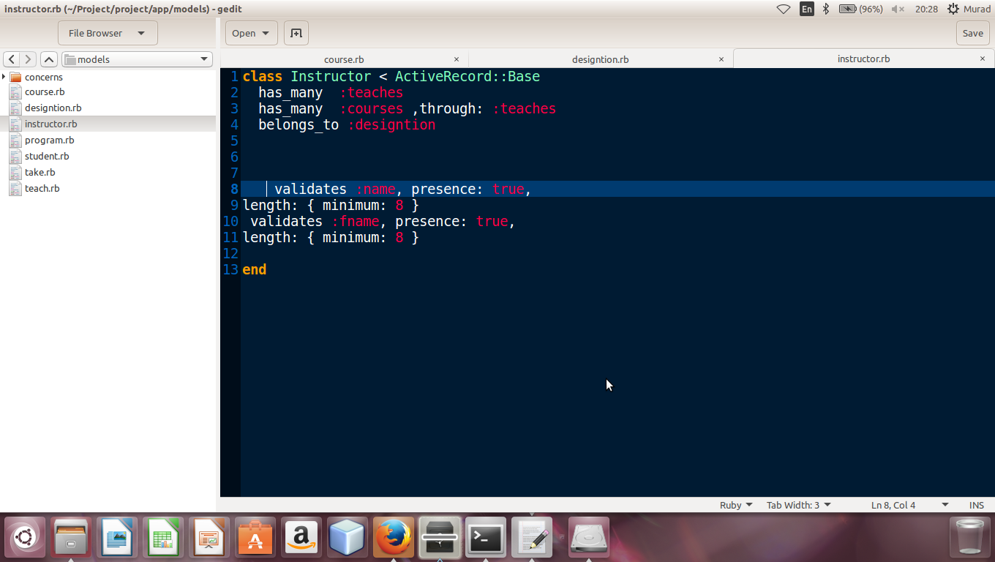

**New instructor form**

As we discussed about new.html.erb form above which show in browzer like this while entering new instructor

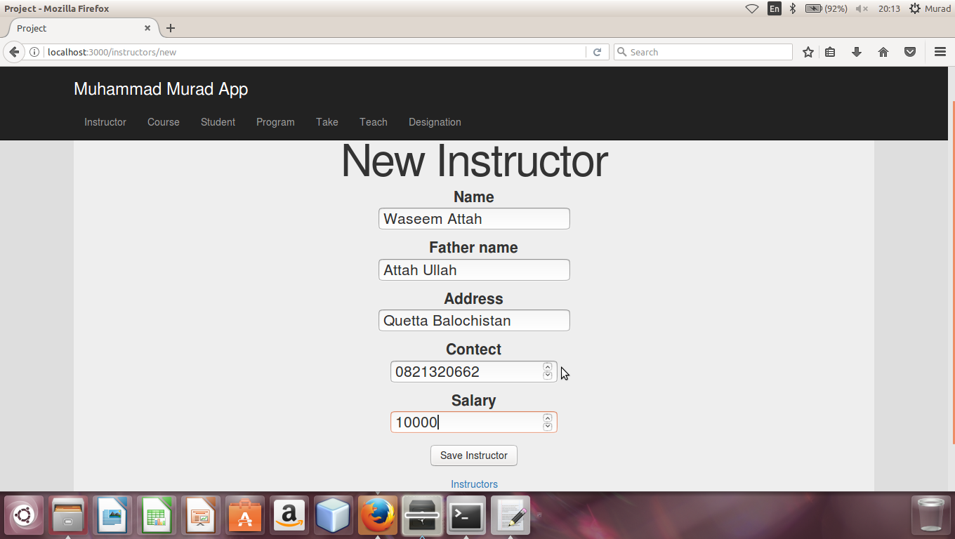

**Show now instructor**

When we entered data in form and click on “save instructor” then new instructor will be shown like this.

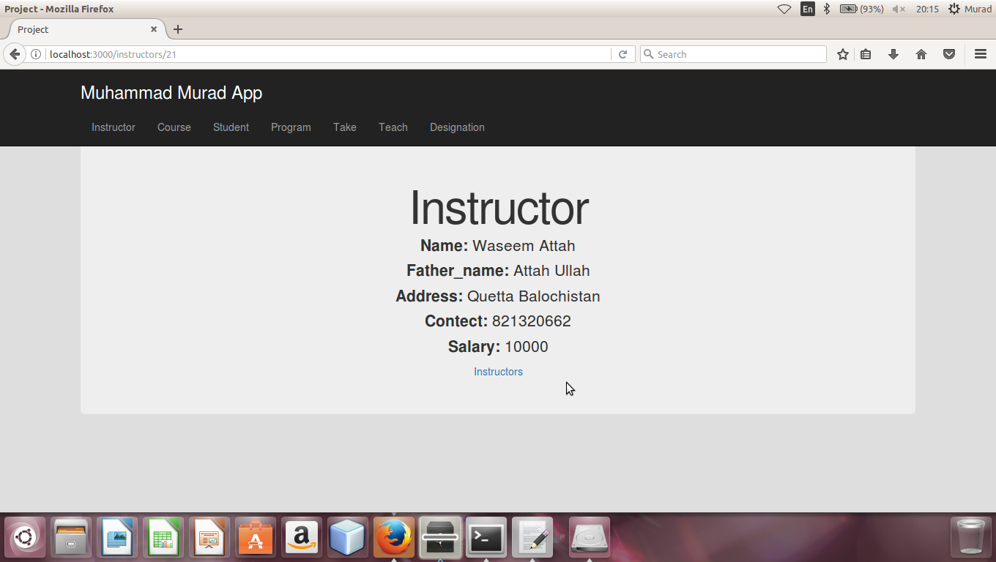

**List of all instructor**

Index.html.erb in view contain listing of all instructor and their the list of instructors in browser shown like this. As you can see blow there is also option for delete , show and edit in a list

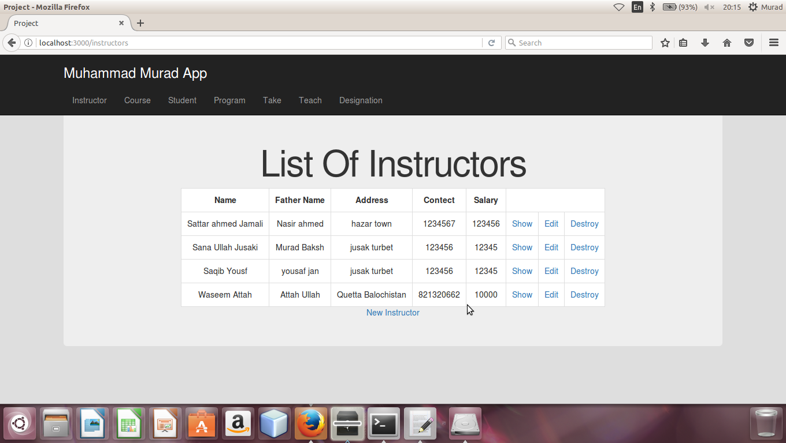

**Generation of course controller**

I have generated the course Controller in Ruby on Rails and we defined all actions of course like save the course index, delete ,edit ,show and update in controller and controller control all these kinds of action as shown in blow figure.

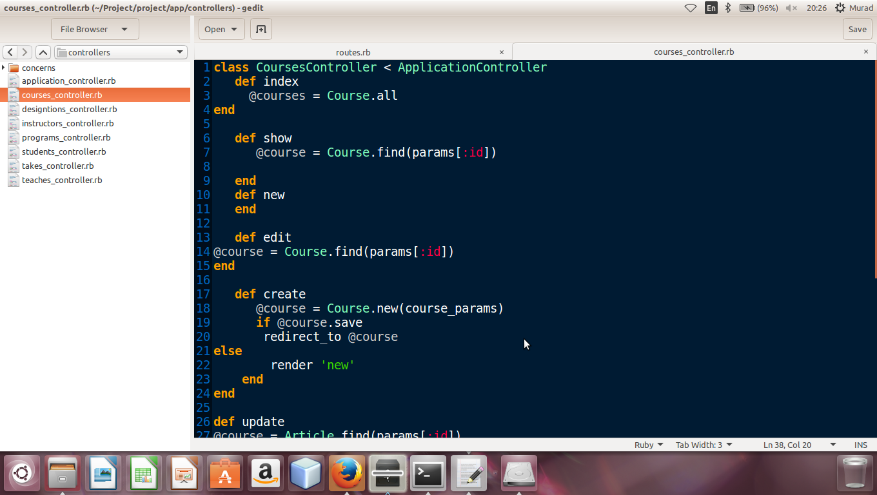

**Generation of Course model**

This is Migration file of course because we have generated the model of course and then we created and migrated its database in ruby on rails

The all attributes of instructor model which we gave with the particular data type while generating course model are also shown in migration file of course

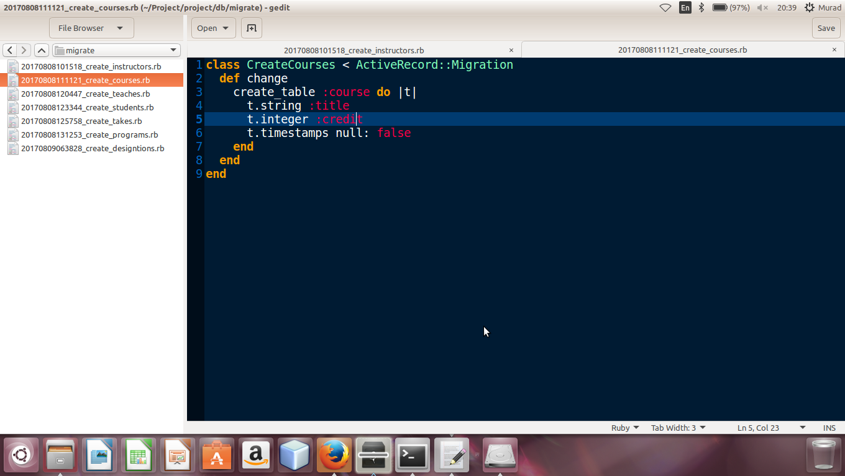

**View of Course model**

View folder of contain the following files which are new.html.erb, show.html.erb, edit.html.erb, index.html.erb ,all files are view file for user hand and action are define for these inside controller. the following files are

**now.html.erb**

it contain a form by this we make now entry for courses

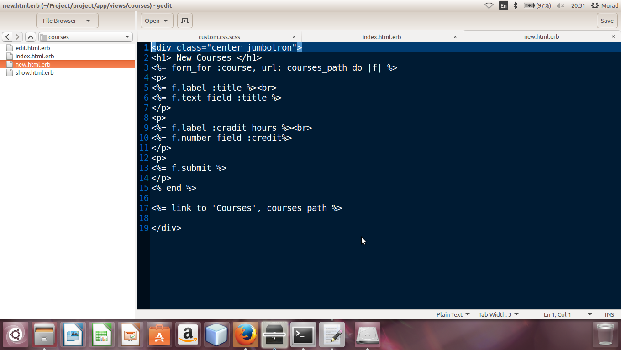

**show.html.erb**When we put a some in a form of instructor and click on save then show table shows a now enterd form only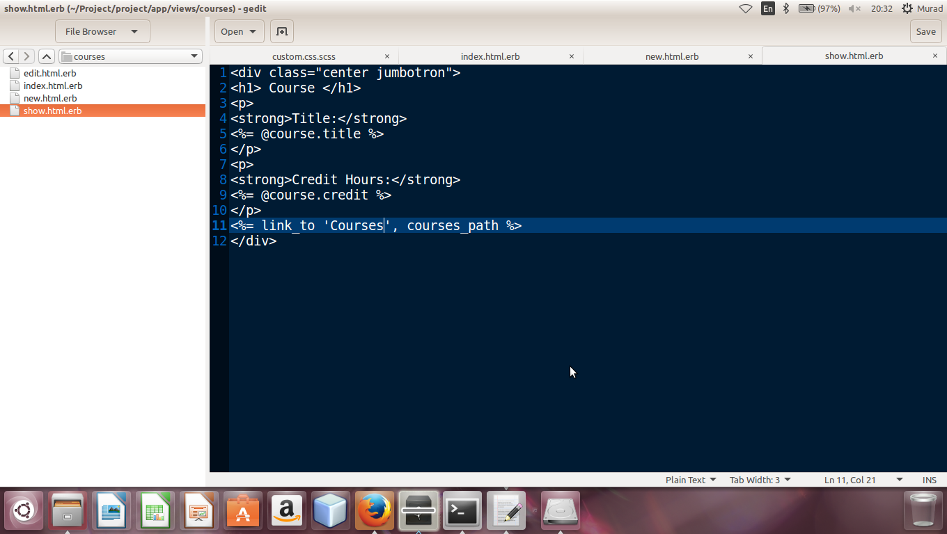

**Index.html.erb**

It contain list of coursess which we entered all courses are shown in a listing order . it also contain delete ,show and edit option in fornt of each course data

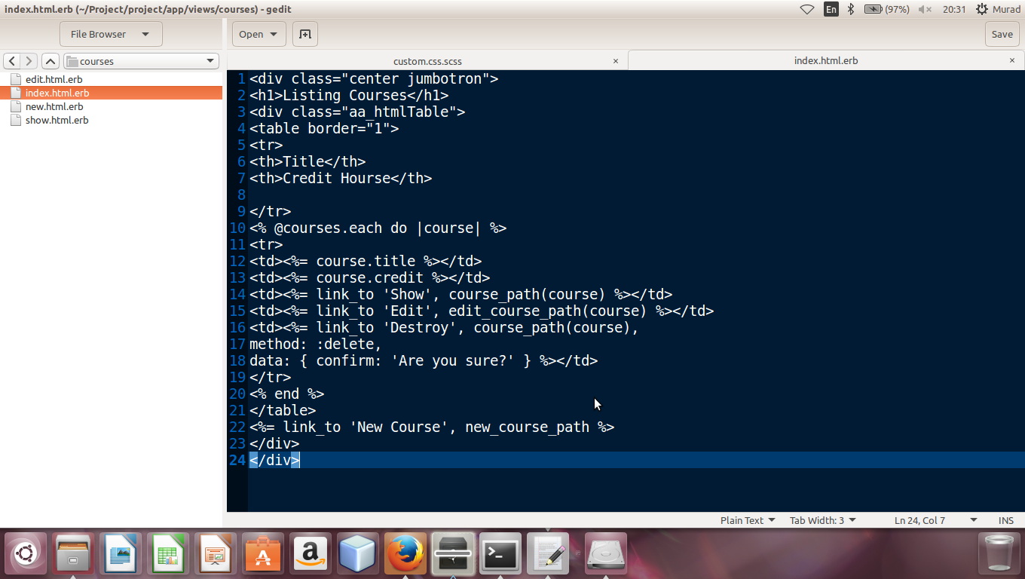

**Model of Course**

In model of course table I showed association of instructor model with others model like instructor model has relation with instructor and student through teaches and takes .Validation on fileds of course table are also set.

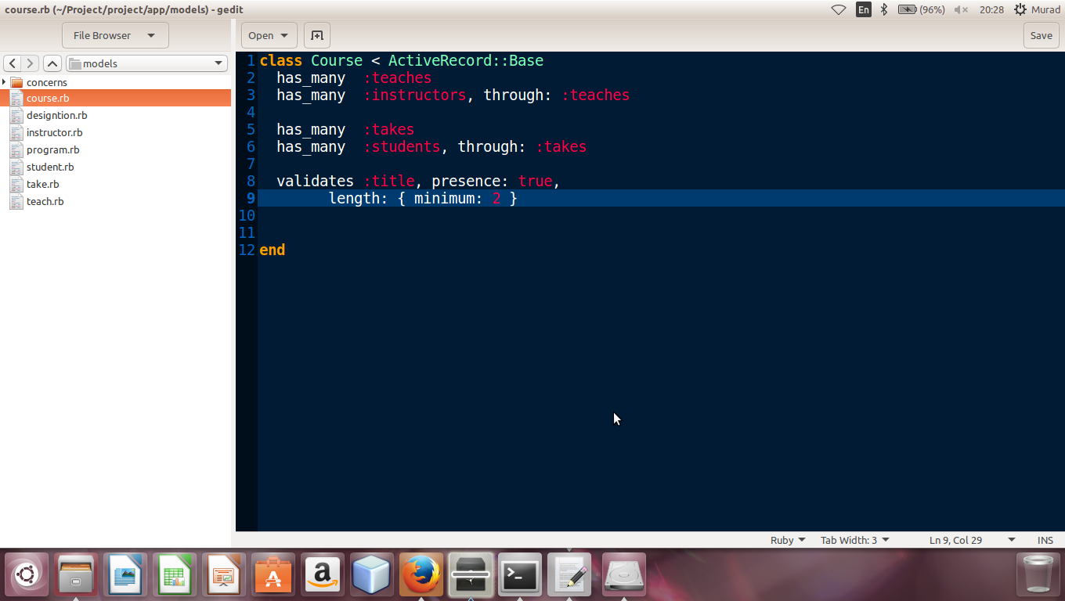

**Now Course**

As we discussed about new.html.erb form above which show in browzer like this while entering new course

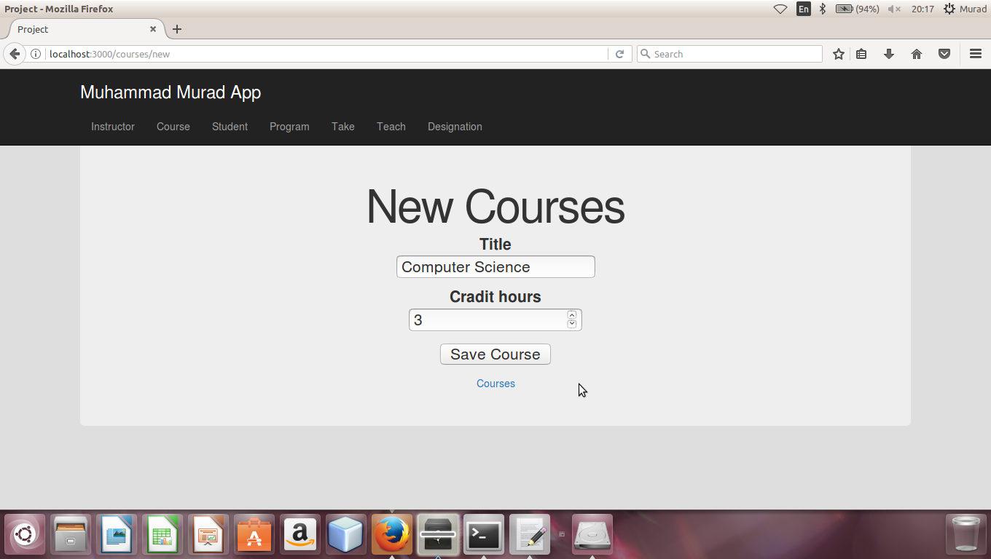

**Show Now Course**

When we entered data in form and click on “Save Course” then new instructor will be shown like this.

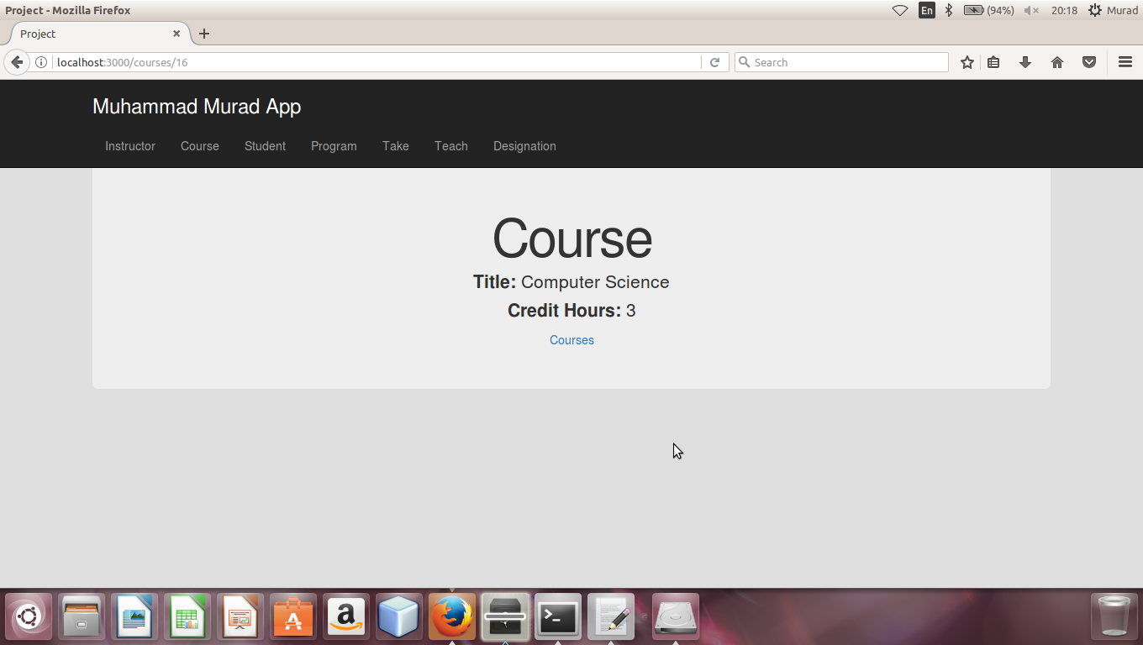

**List Of All Course**

Index.html.erb in view contain listing of all course and their the list of courses in browser shown like this. As you can see blow there is also option for delete , show and edit in a list

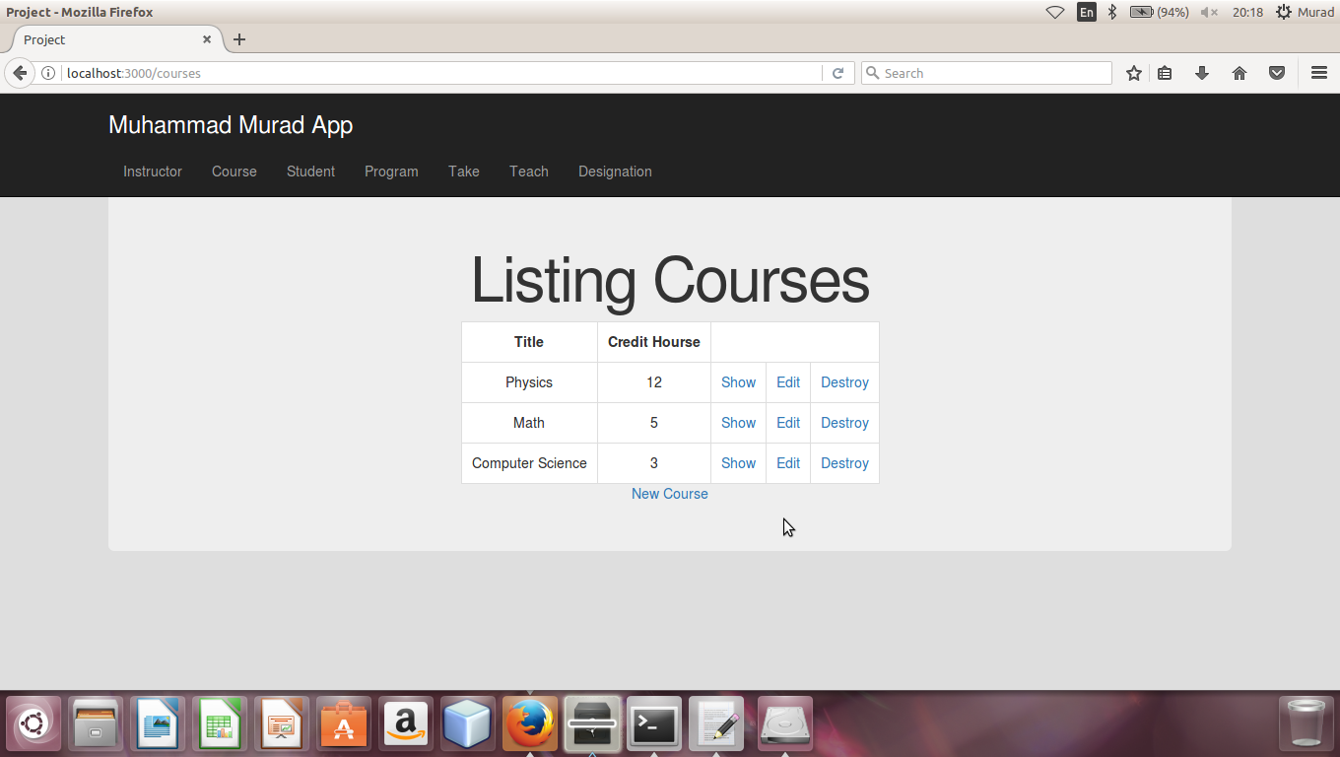

**Generation of Teaches (diamond) controller**

I have generated the teach Controller in Ruby on Rails and we defined all actions of teaches like save the save index, delete ,edit ,show and update in controller and controller control all these kinds of action as shown in blow figure.

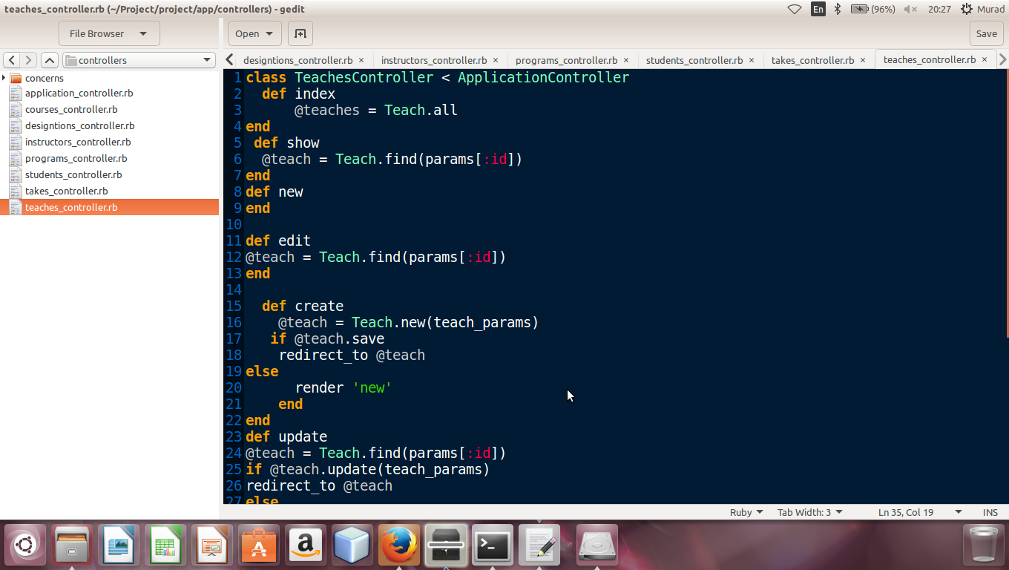

**Generation of Teaches model**

This is Migration file of teaches because we have generated the model of teaches and then we created and migrated its database in ruby on rails

The all attributes of teaches model which we gave with the particular data type while generating course model are also shown in migration file of teaches

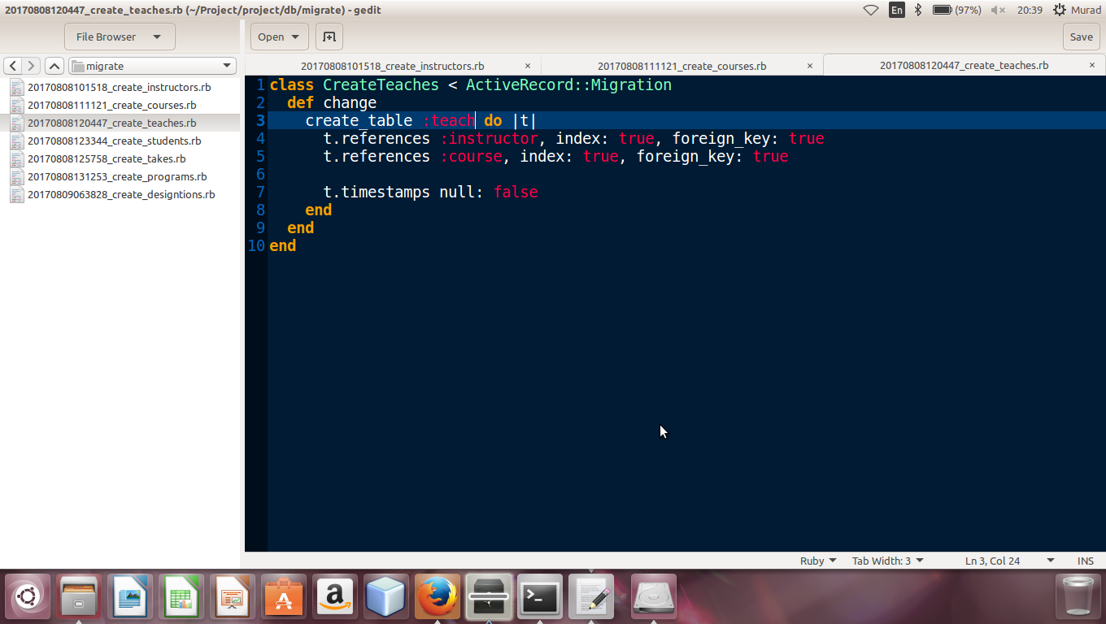

**View of Teaches model**

View folder of contain the following files which are new.html.erb, show.html.erb, edit.html.erb, index.html.erb ,all files are view file for user hand and action are define for these inside controller. the following files are

**now.html.erb**

it contain a form by this we make now entry for teaches

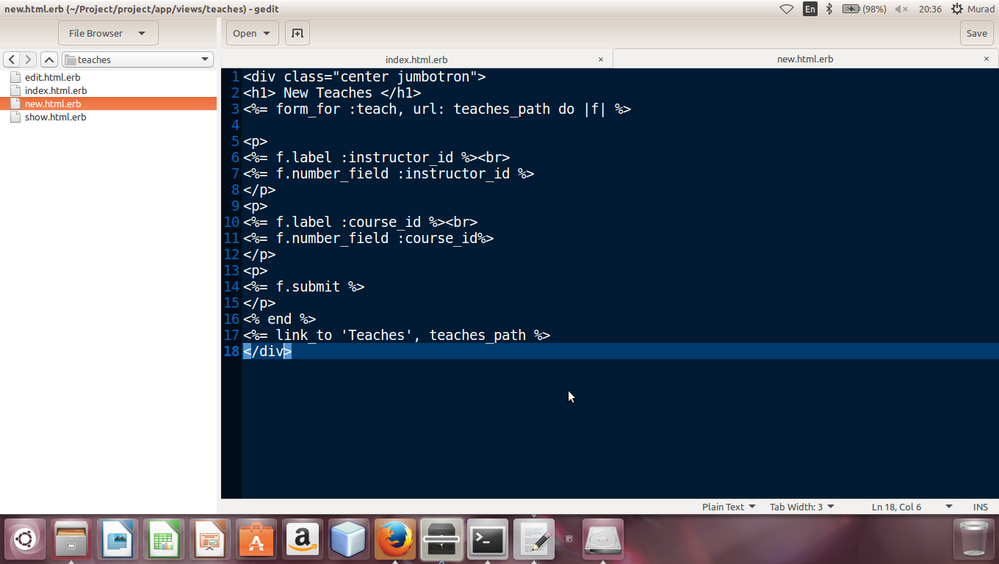

**show.html.erb**When we put a some in a form of teaches and click on save then show table shows a now enterd form only

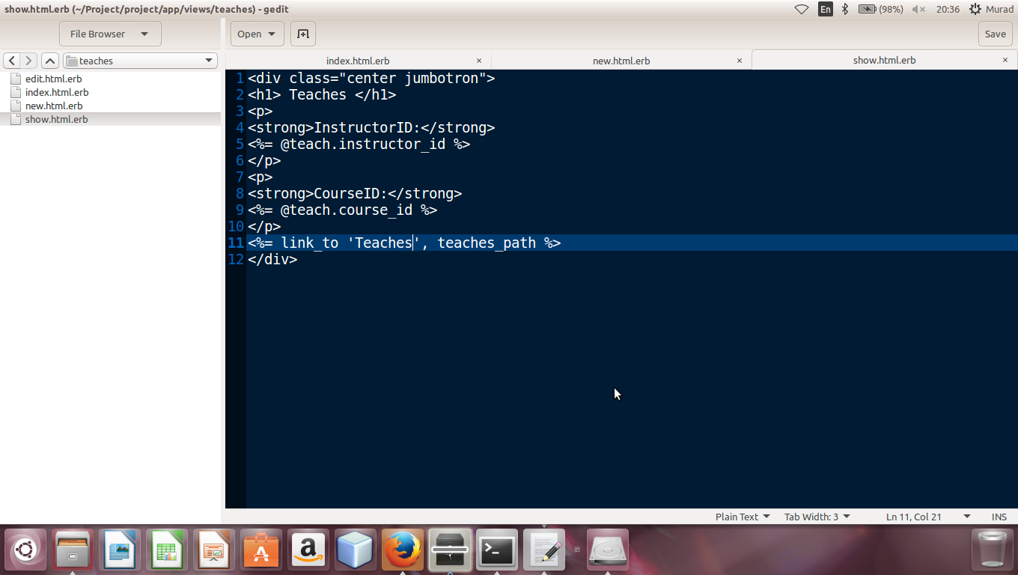

**Index.html.erb**

It contain list of teaches which we entered all courses are shown in a listing order . it also contain delete ,show and edit option in fornt of each teaches data

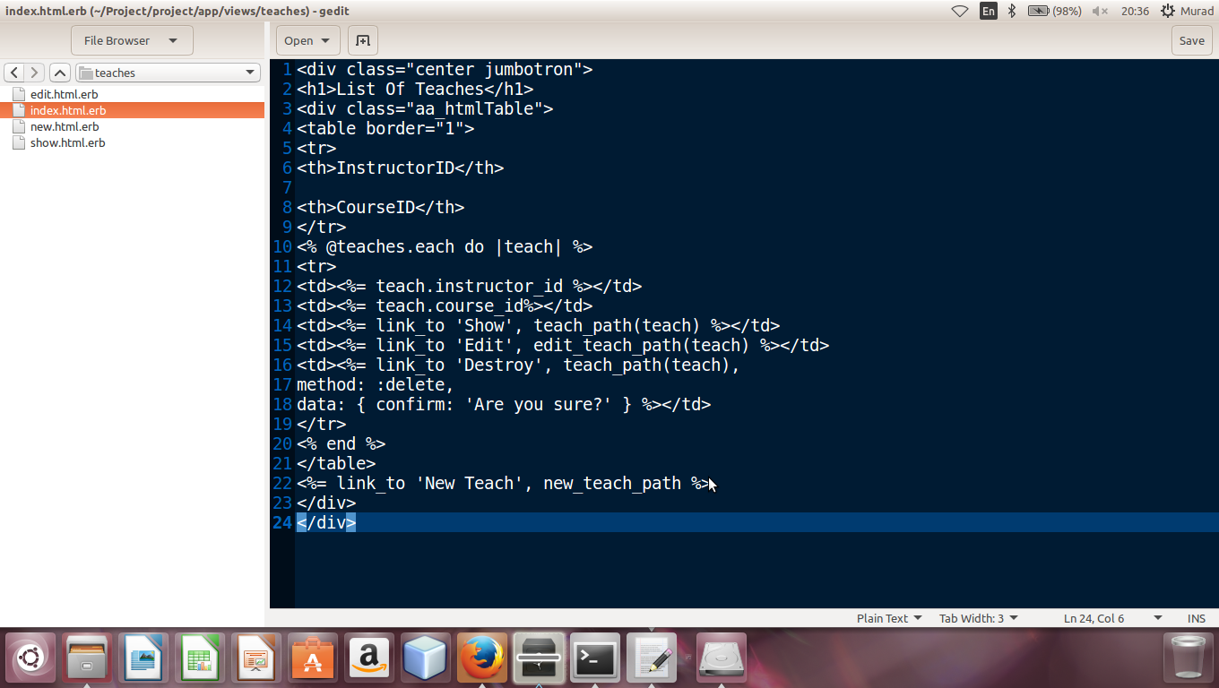

**Model of Teaches**

In model of teachea table I showed association of teaches model with others model like instructor model and course model .Validation on fileds of teaches table are also set.

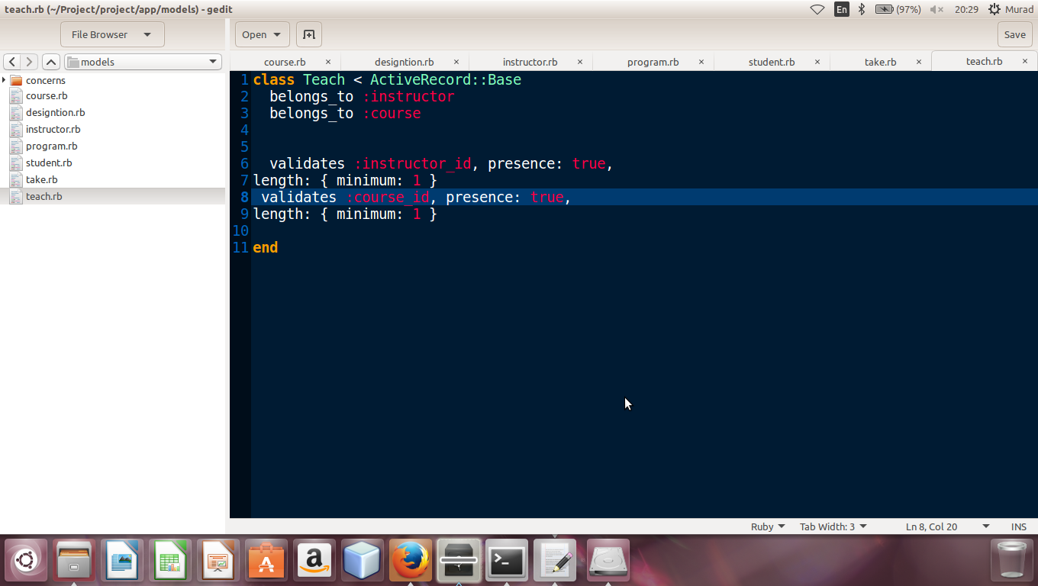

**Now Teaches**

As we discussed about new.html.erb form above which show in browzer like this while entering new teaches

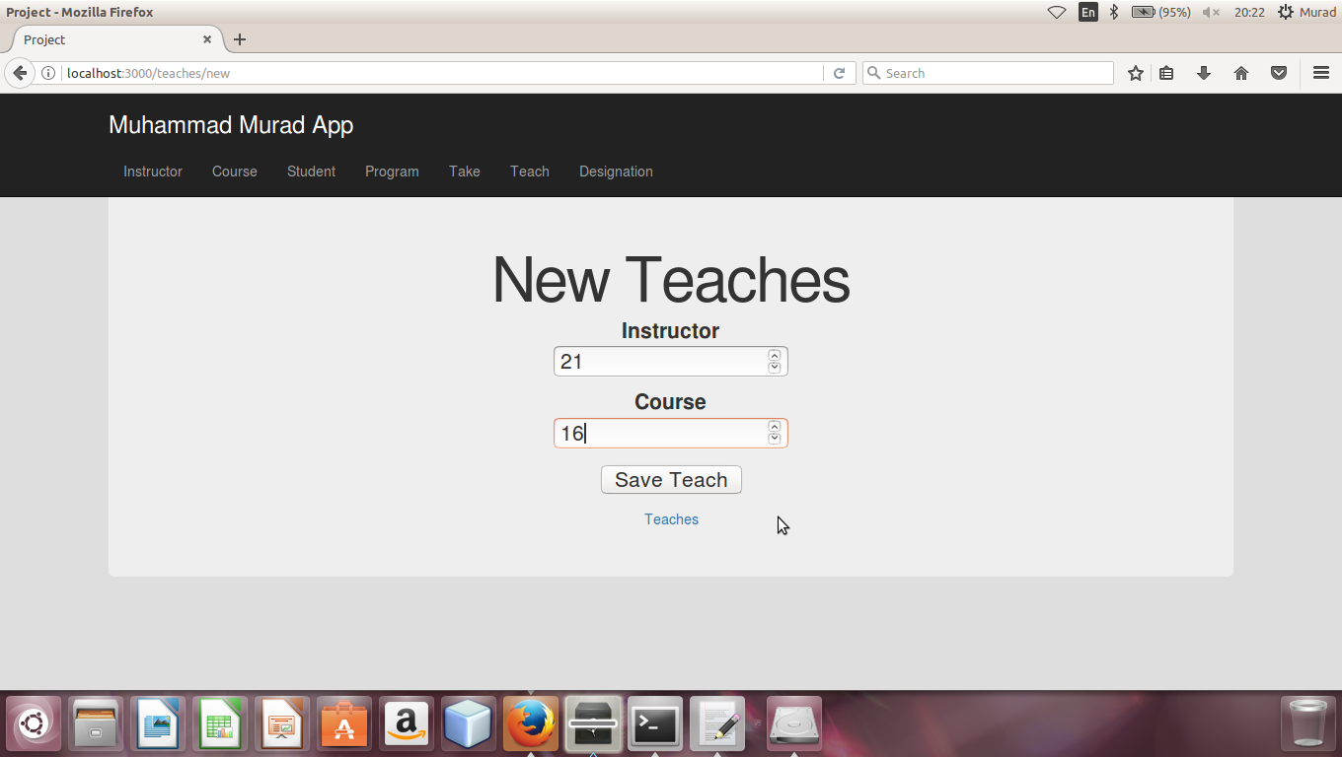

**Show Now Teaches**

When we entered data in form and click on “Save Teaches” then new instructor will be shown like this.

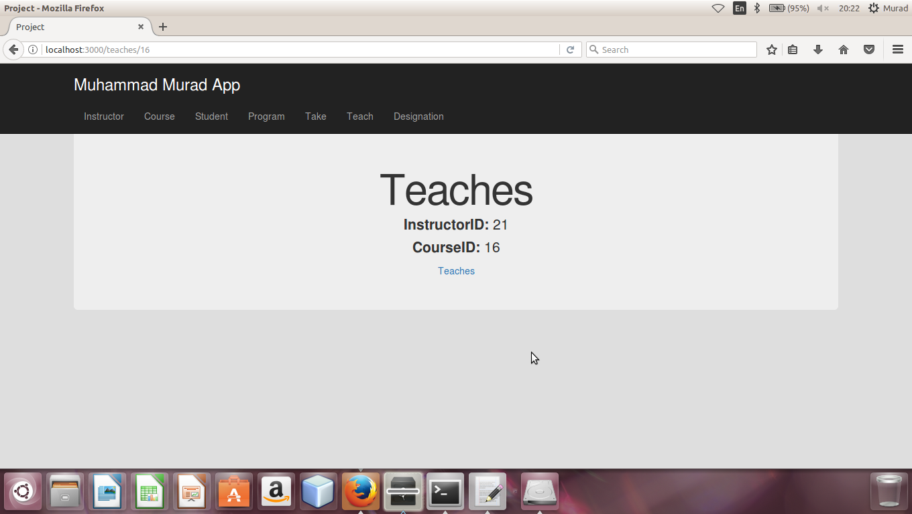

**List Of All Teaches**

Index.html.erb in view contain listing of all Teaches and the list of Teaches in browser shown like this. As you can see blow there is also option for delete , show and edit in a list.

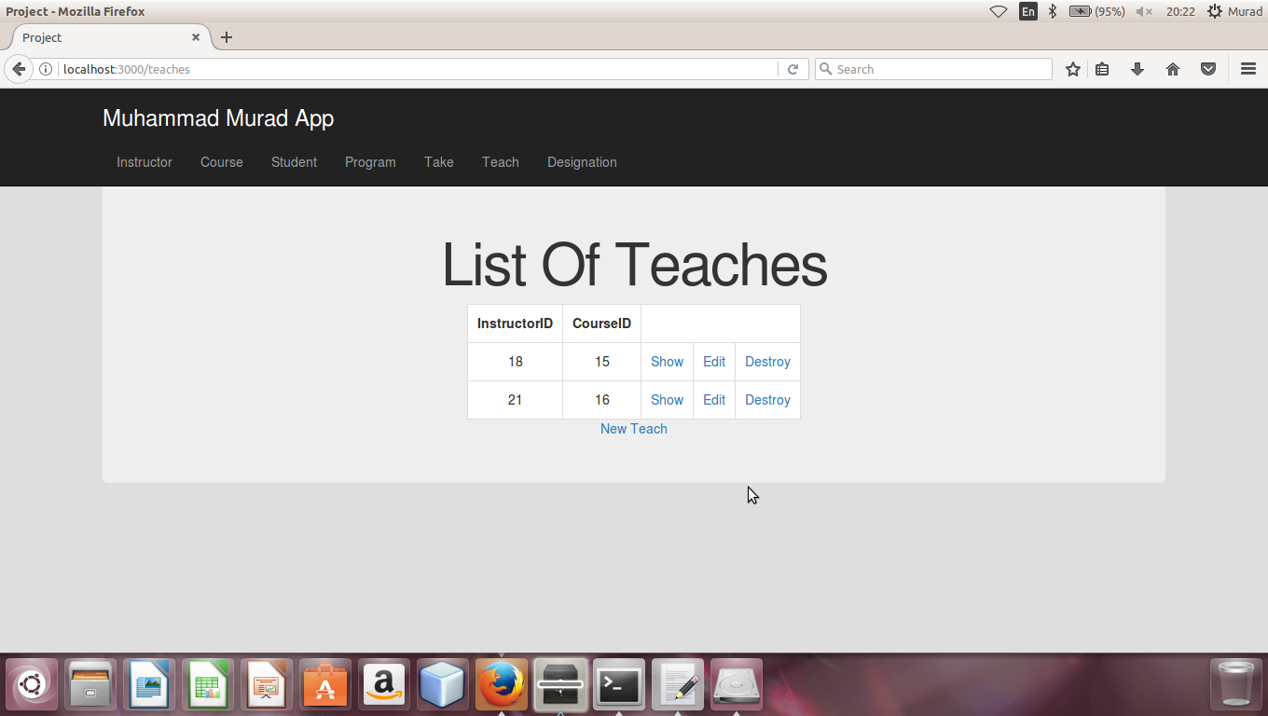

**Generation of Student controller**

I have generated the student Controller in Ruby on Rails and we defined all actions of student like save the course index, delete ,edit ,show and update in controller and controller control all these kinds of action as shown in blow figure.

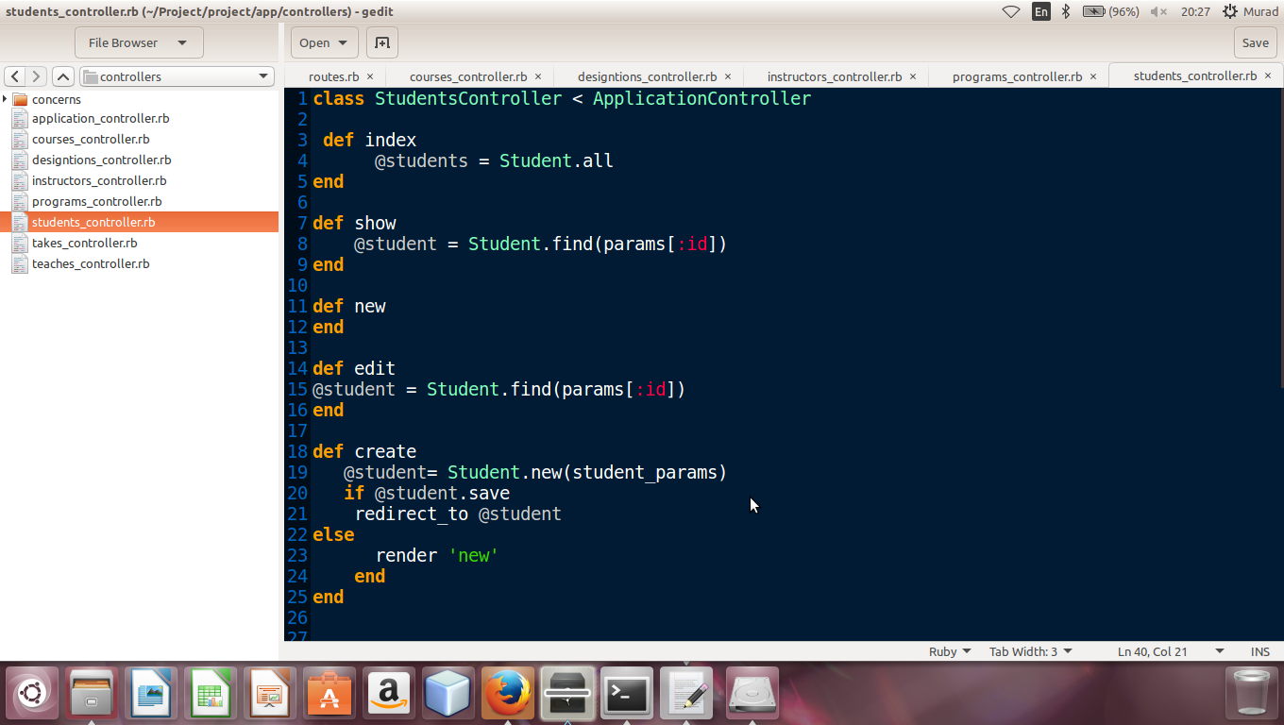

**Generation of Student model**

This is Migration file of student because we have generated the model of student and then we created and migrated its database in ruby on rails

The all attributes of student model which we gave with the particular data type while generating course model are also shown in migration file of student

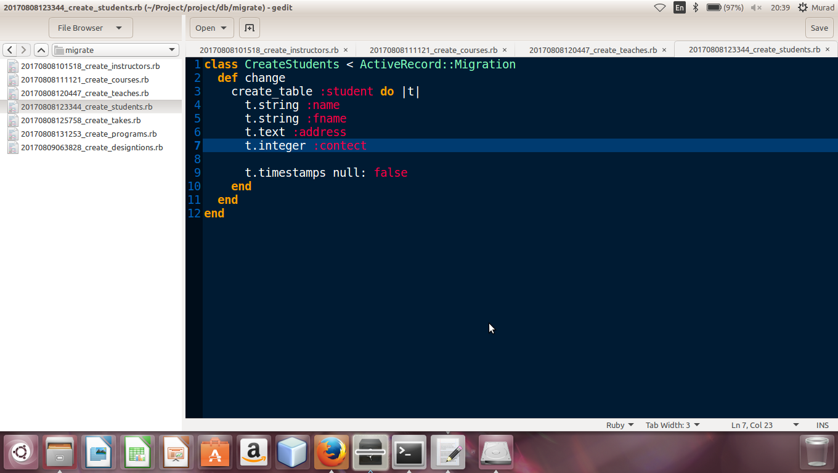

**View of Student model**

View folder of contain the following files which are new.html.erb, show.html.erb, edit.html.erb, index.html.erb ,all files are view file for user hand and action are define for these inside controller. following files are.

**now.html.erb**

it contain a form by this we make now entry for student.

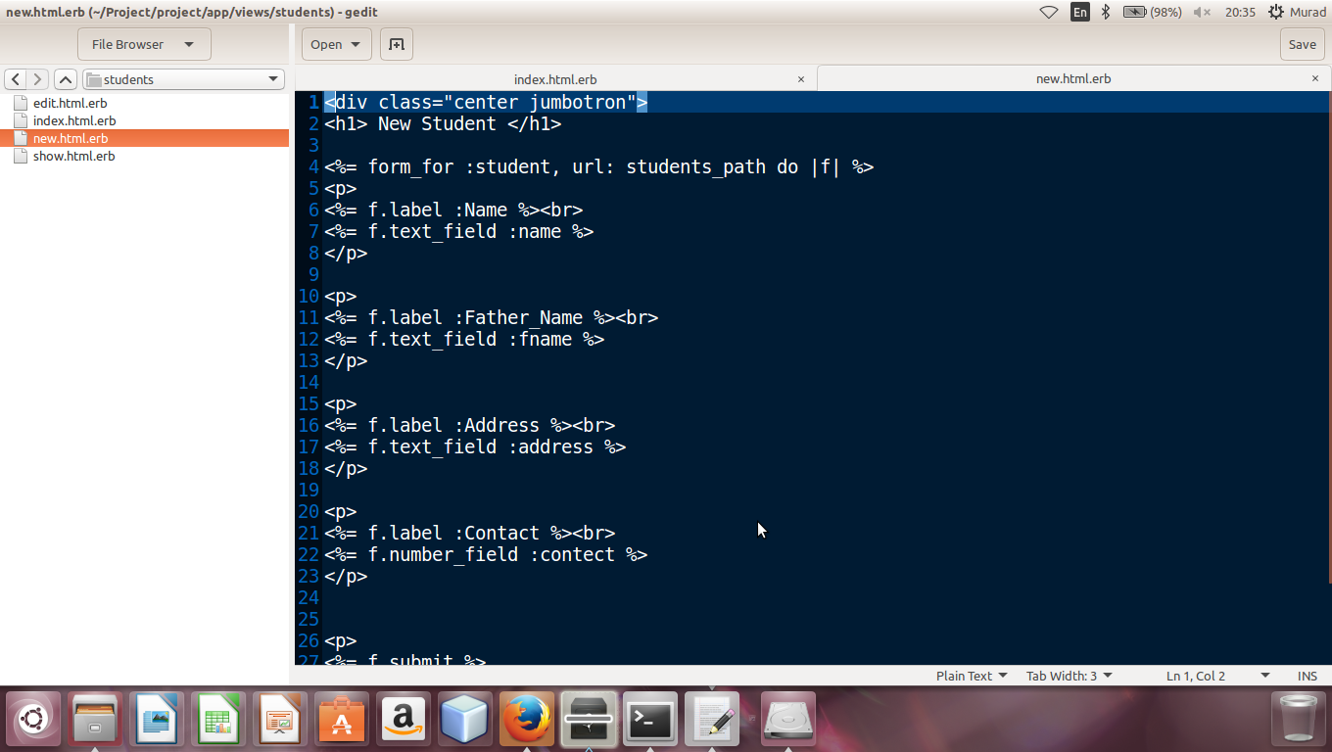

**show.html.erb**

When we put a some in a form of student and click on save then show table shows a now enterd form only

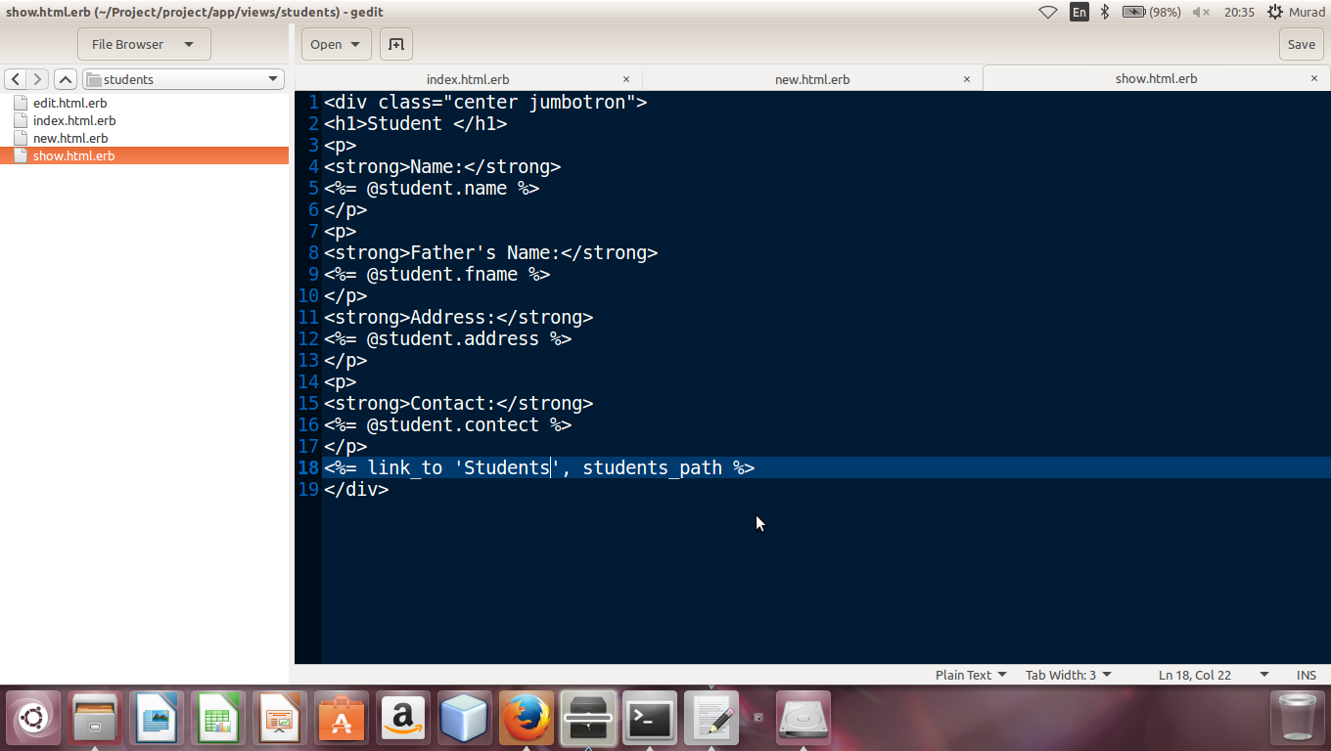

**Index.html.erb**

It contain list of students which we entered all student are shown in a listing order . it also contain delete ,show and edit option in fornt of each students data.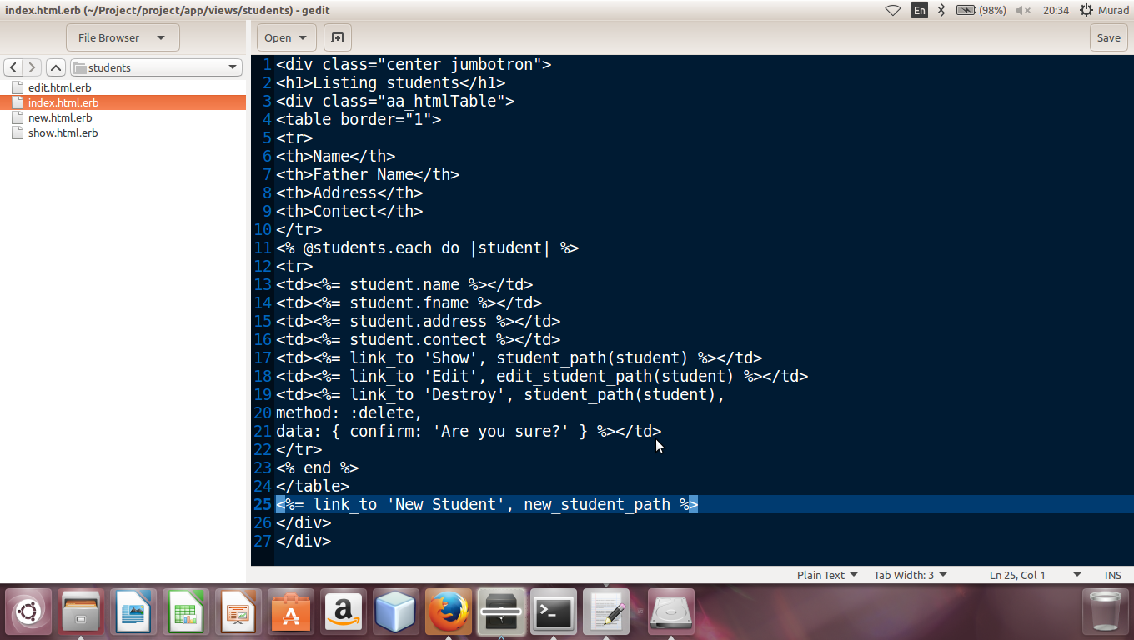

**Model of Student**

In model of student table I showed association of student model with others model like course model and program model .Validation on fileds of student table are also set.

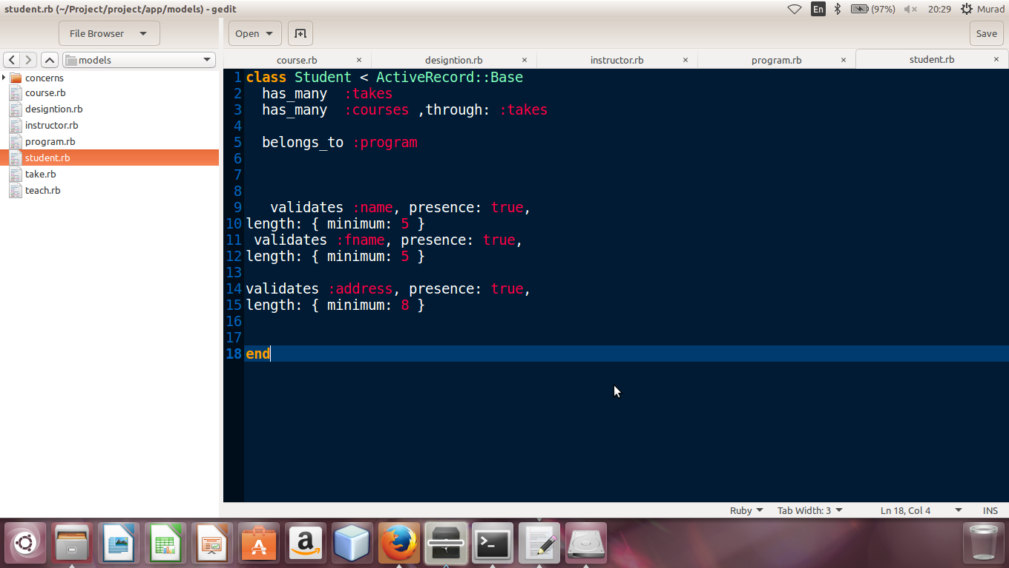

**Now Student**

As we discussed about new.html.erb form above which show in browzer like this while entering new student

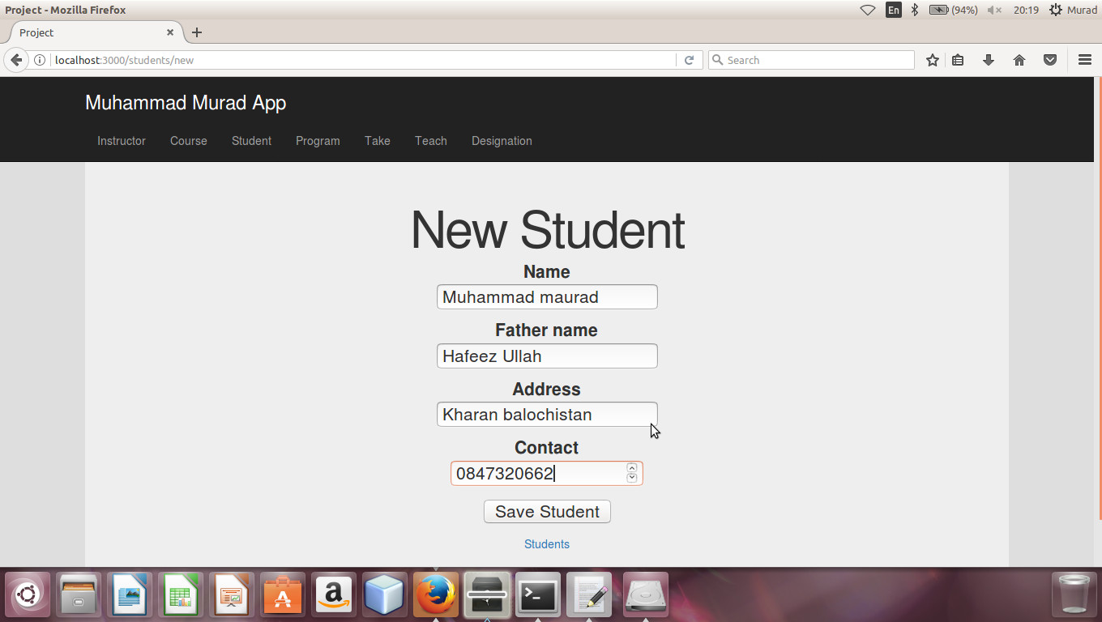

**Show Now Student**

When we entered data in form and click on “Save Student” then new student will be shown like this.

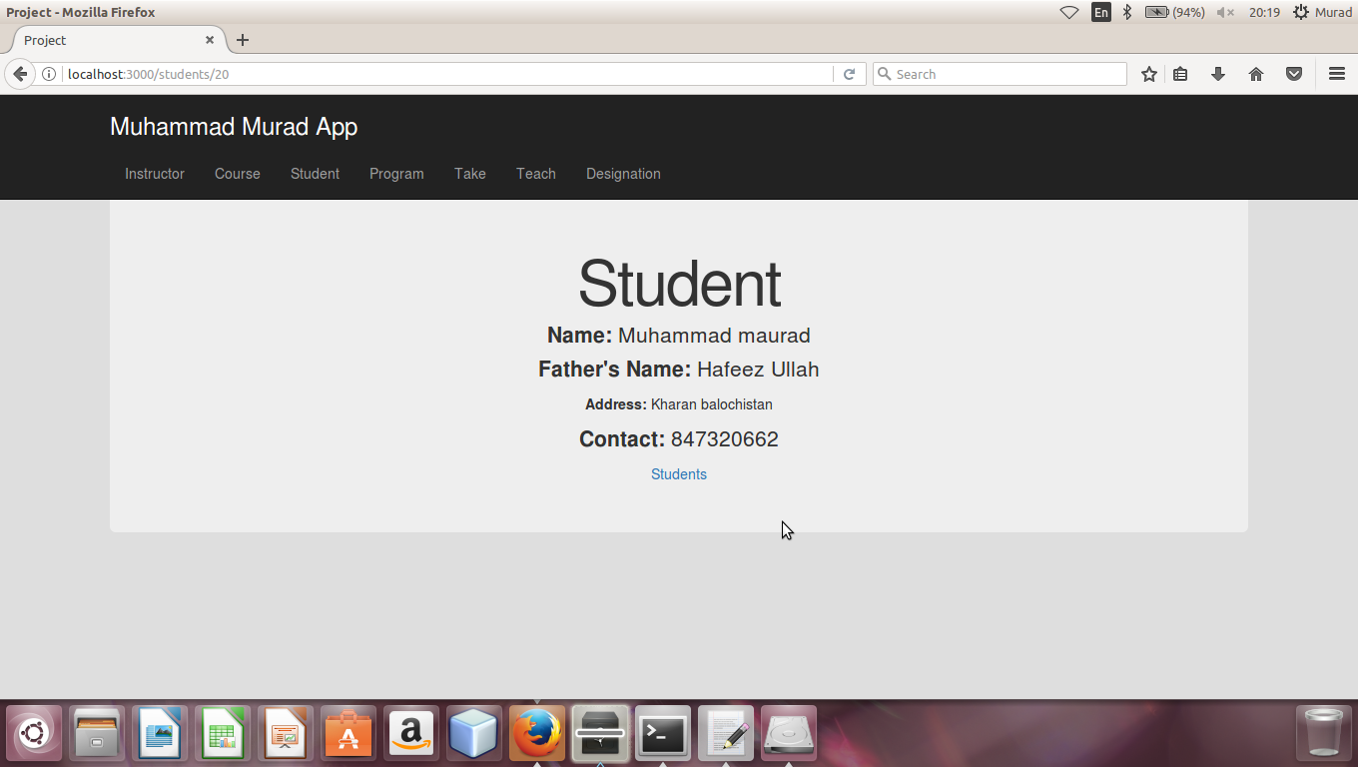

**List of Student**

Index.html.erb in view contain listing of all student and the list of student in browser shown like this. As you can see blow there is also option for delete , show and edit in a list.

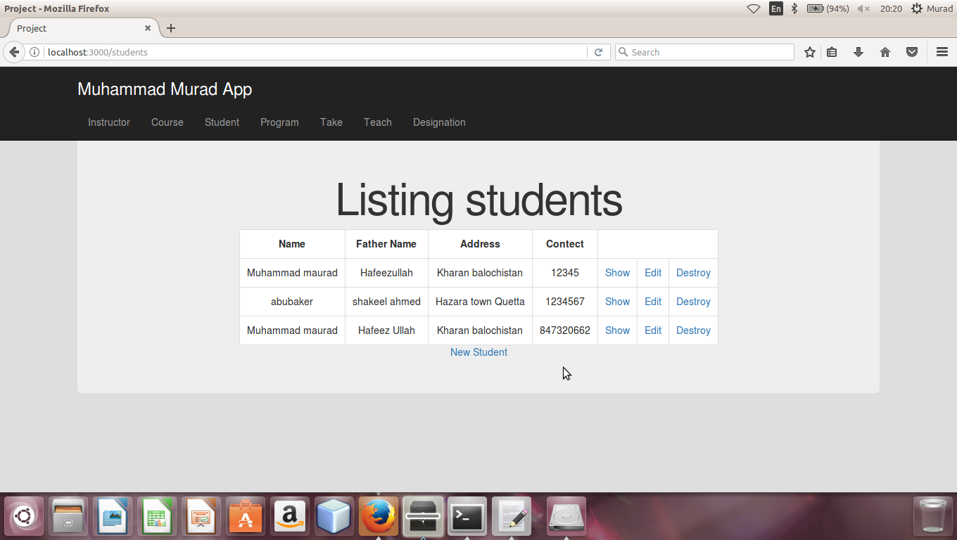

**Generation of Takes(diamond) controller**

I have generated the takes Controller in Ruby on Rails and we defined all actions of takes likes save the course index, delete ,edit ,show and update in controller and controller control all these kinds of action as shown in blow figure.

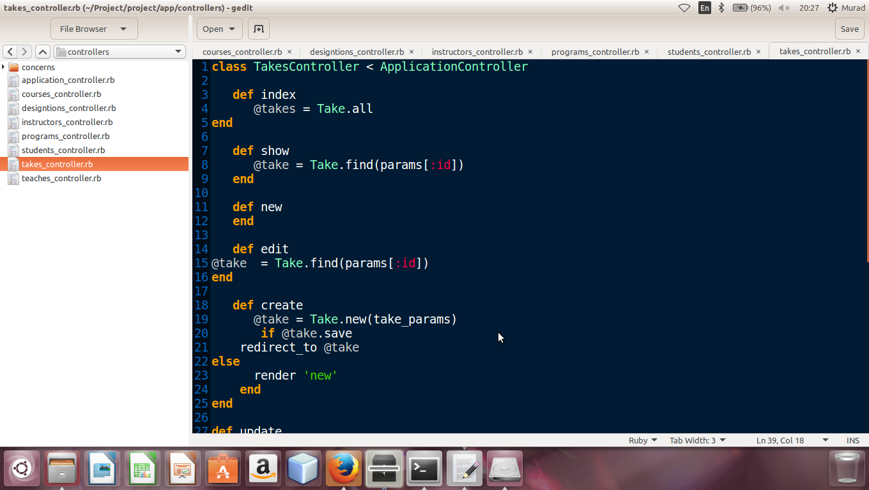

**Generation of Takes model**

This is Migration file of takes because we have generated the model of take and then we created and migrated its database in ruby on rails

The all attributes of takes model which we gave with the particular data type while generating takes model are also shown in migration file of takes

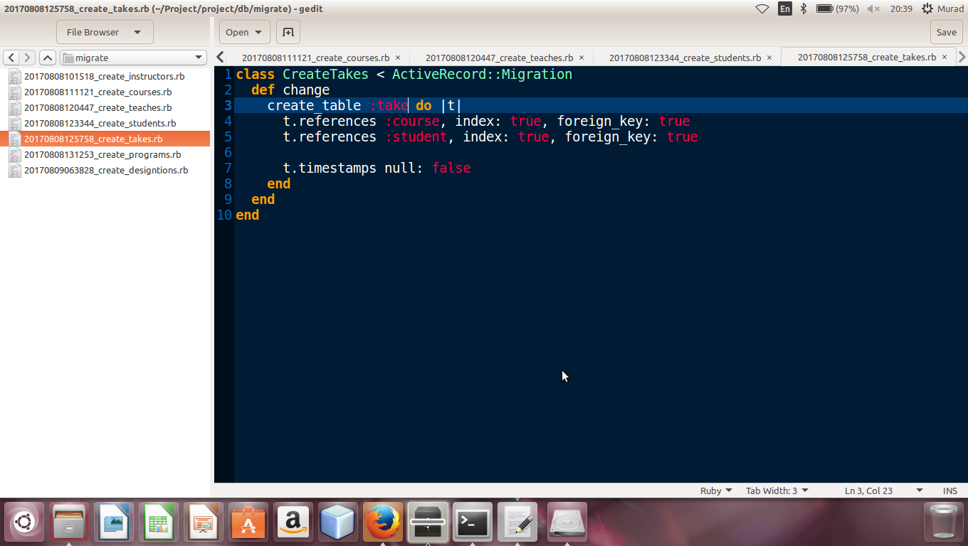

**View of Takes model**

View folder of contain the following files which are new.html.erb, show.html.erb, edit.html.erb, index.html.erb ,all files are view file for user hand and action are define for these inside controller. the following files are

**now.html.erb**

It contain a form by this we make now entry for takes.

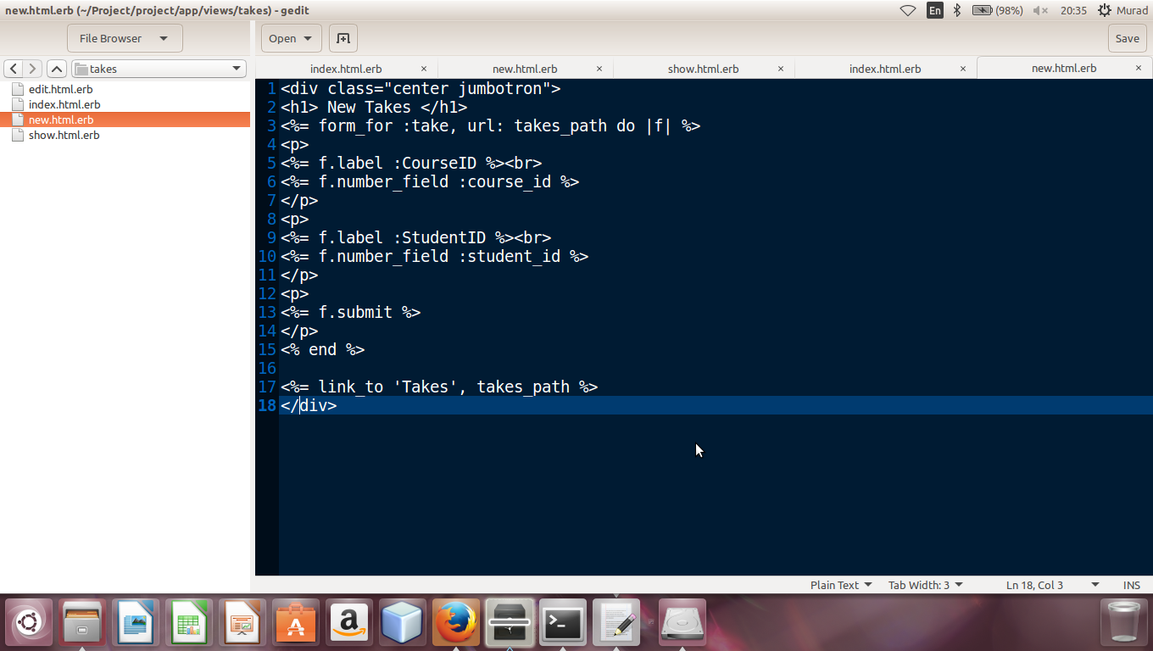

**show.html.erb**

When we put a some data in a form of take and click on save then show table shows a now enterd form only.

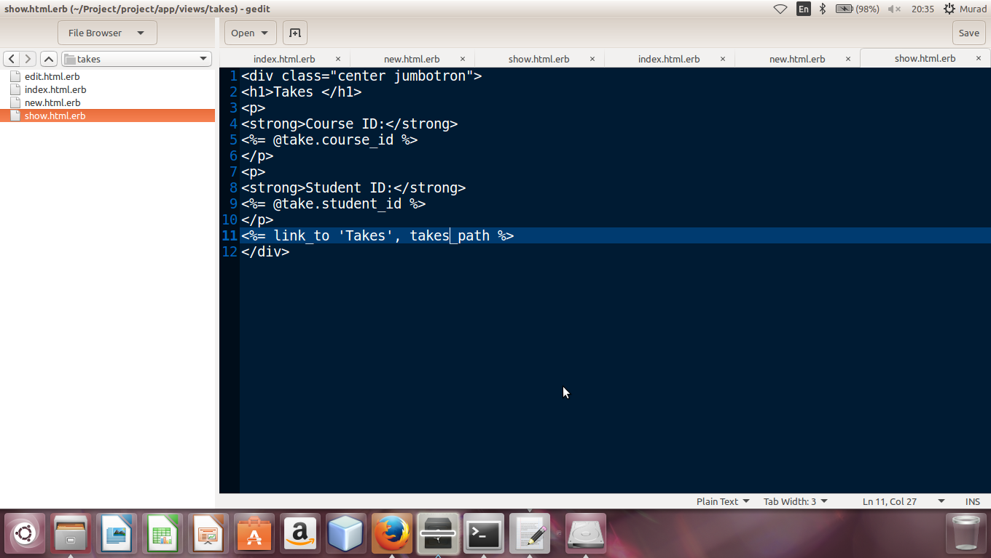

**Index.html.erb**

It contain list of takes which we entered. all take are shown in a listing order . it also contain delete ,show and edit option in fornt of each take data.

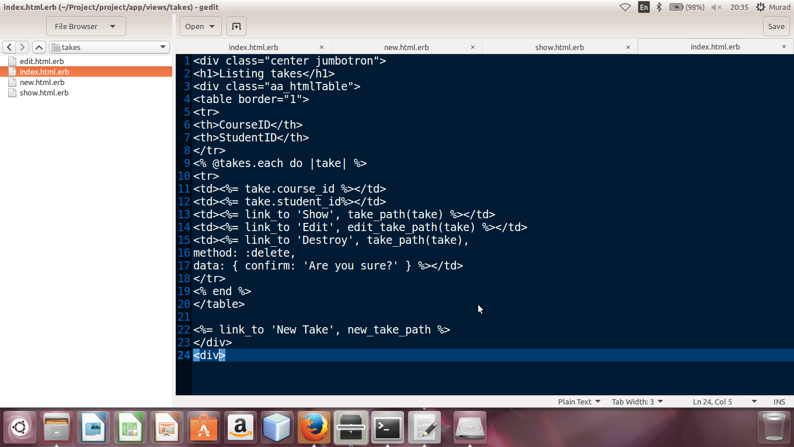

**Model of Takes**

In model of takes table I showed association of takes model with others model like course model and student model .Validation on fileds of takes table are also set.

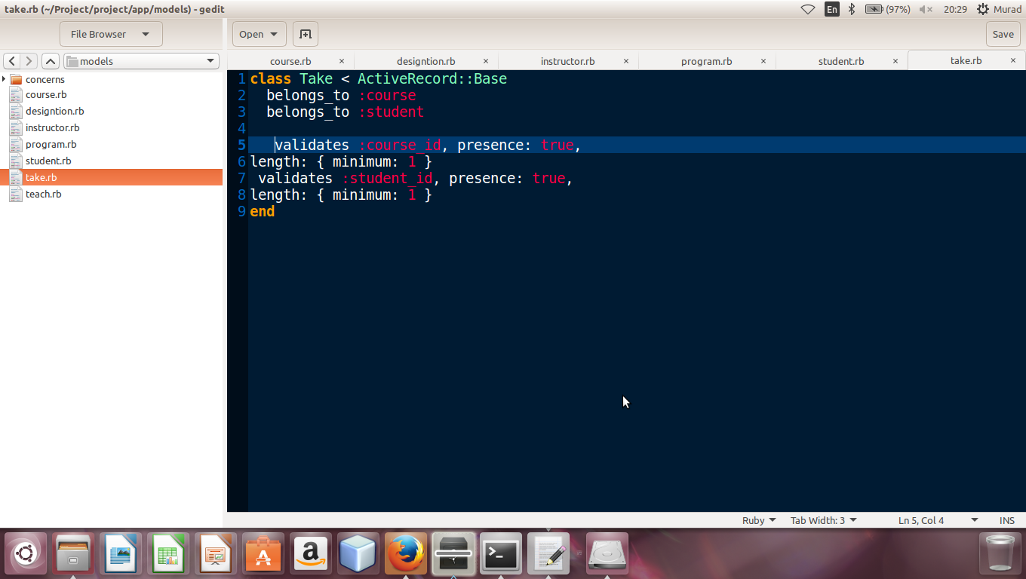

**Now Takes**

As we discussed about new.html.erb form above which show in browzer like this while entering new takes

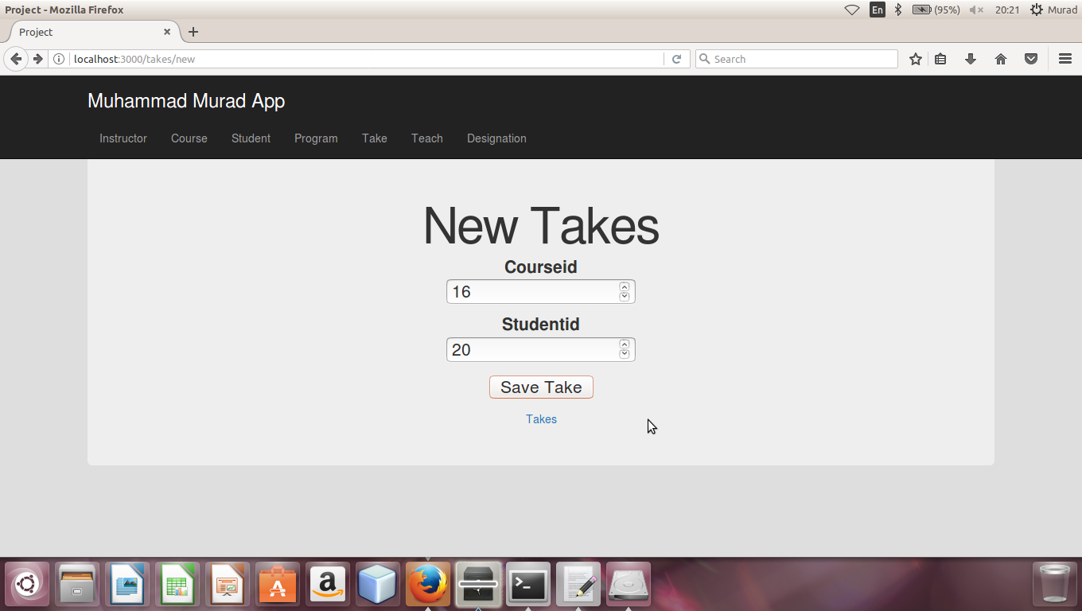

**Show Now Takes**

When we entered data in form and click on “Save Takes” then new takes will be shown like this.

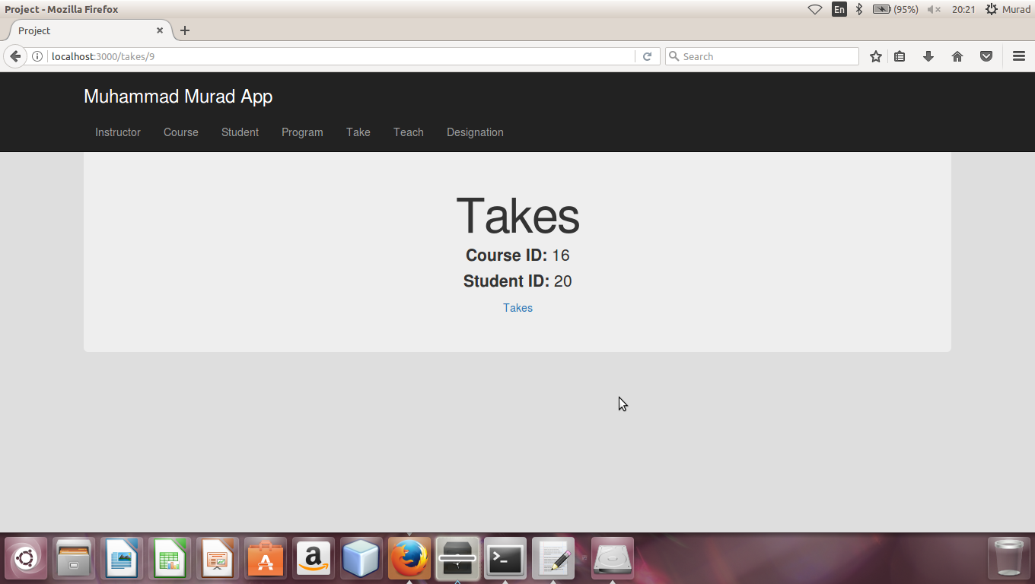

**List Of All takes**

Index.html.erb in view contain listing of all take sand the list of takes in browser shown like this. As you can see blow there is also option for delete show and edit in a list.

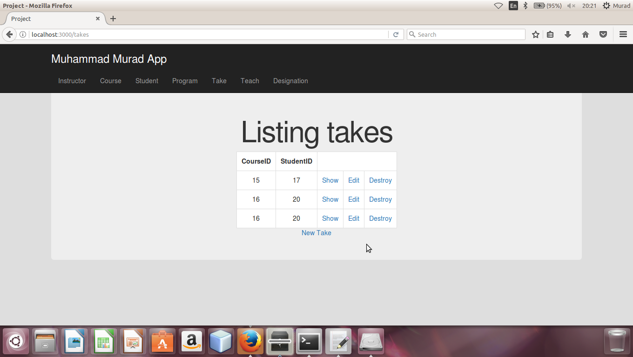

**Generation of Program controller**

I have generated the program Controller in Ruby on Rails and we defined all actions of program likes save the course index, delete ,edit ,show and update in controller and controller control all these kinds of action as shown in blow figure

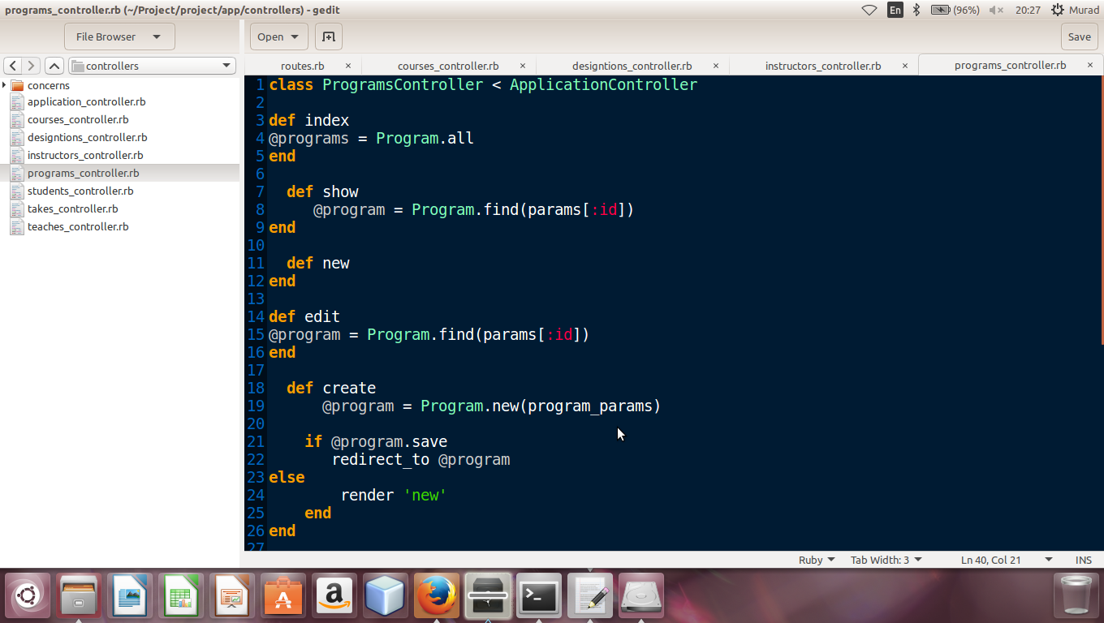

**Generation of Program model**

This is Migration file of program because we have generated the model of program and then we created and migrated its database in ruby on rails. The all attributes of program model which we gave with the particular data type while generating program, model is also shown in migration file of program

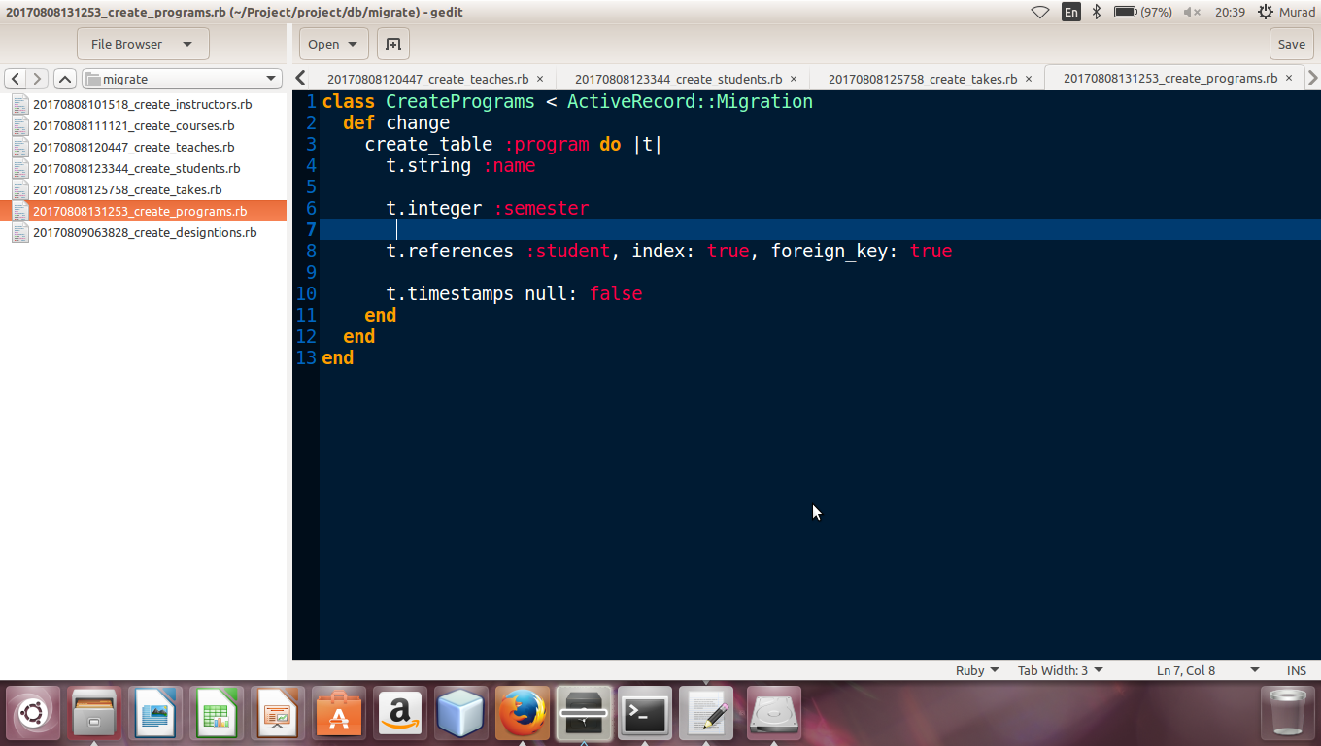

**View of Program model**

View folder of contain the following files which are new.html.erb, show.html.erb, edit.html.erb, index.html.erb ,all files are view file for user hand and action are define for these inside controller. the following files are

**now.html.erb**

it contain a form by this we make now entry for program

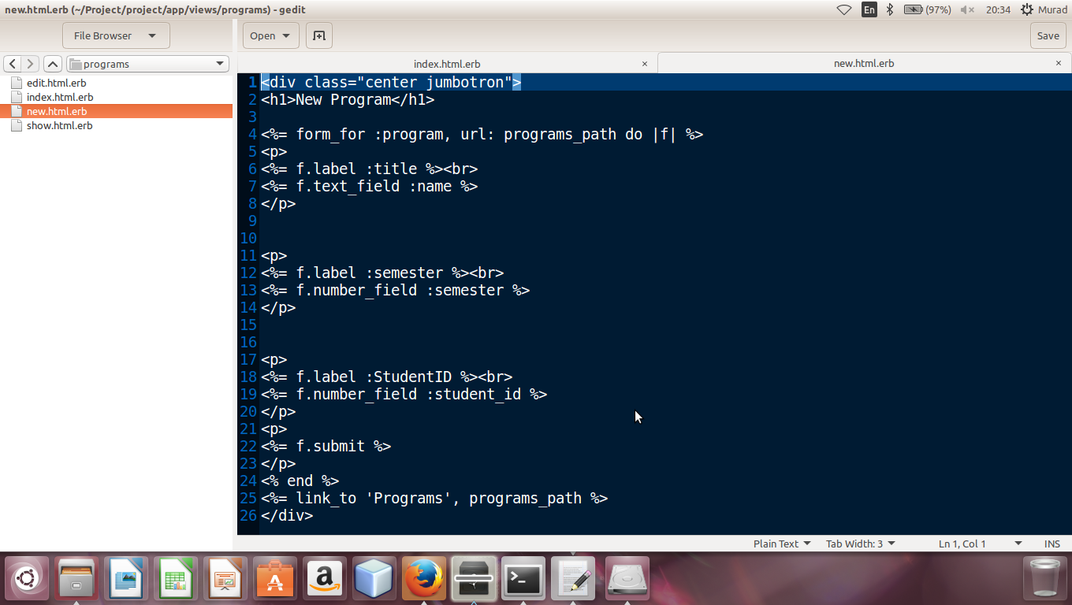

**show.html.erb**

When we put a some data in a form of program and click on save then show table shows a now enterd form only

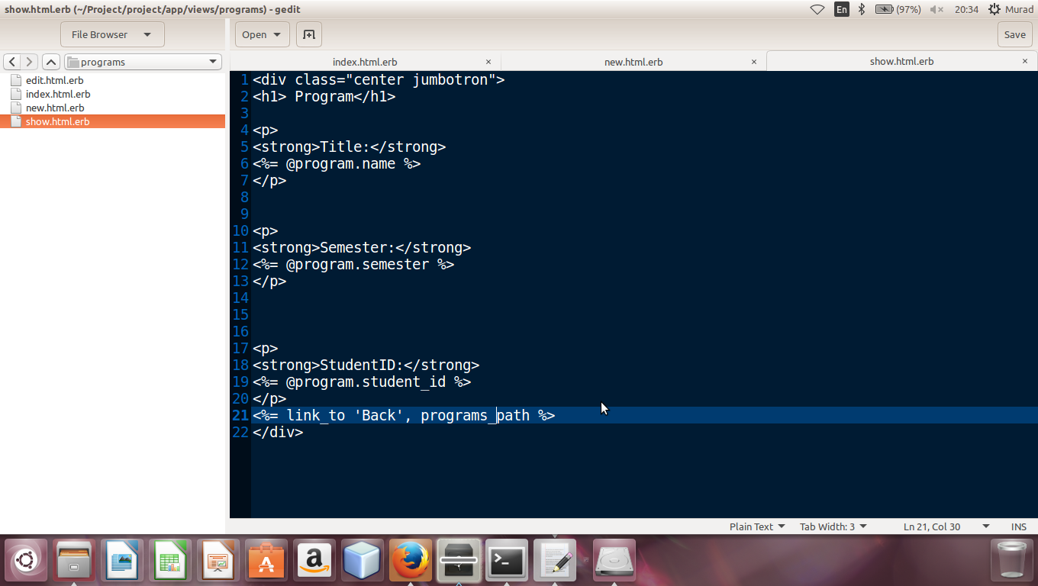

**Index.html.erb**

It contain list of program which we entered. All programs are shown in a listing order . it also contain delete ,show and edit option in fornt of each take data.

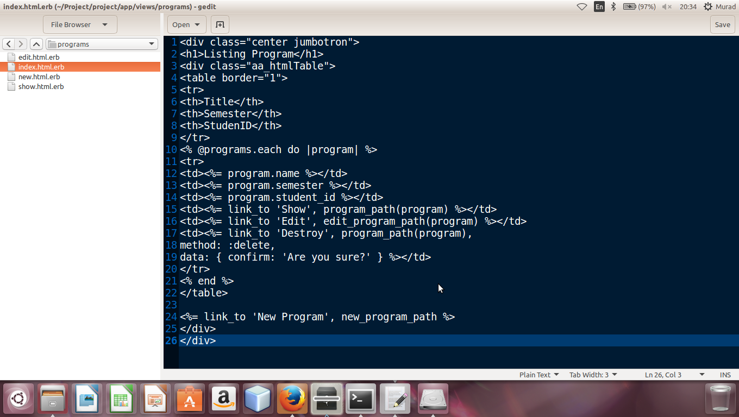

**Model of Program**

In model of program table I showed association of program model with others model like student model .Validation on fileds of program table are also set

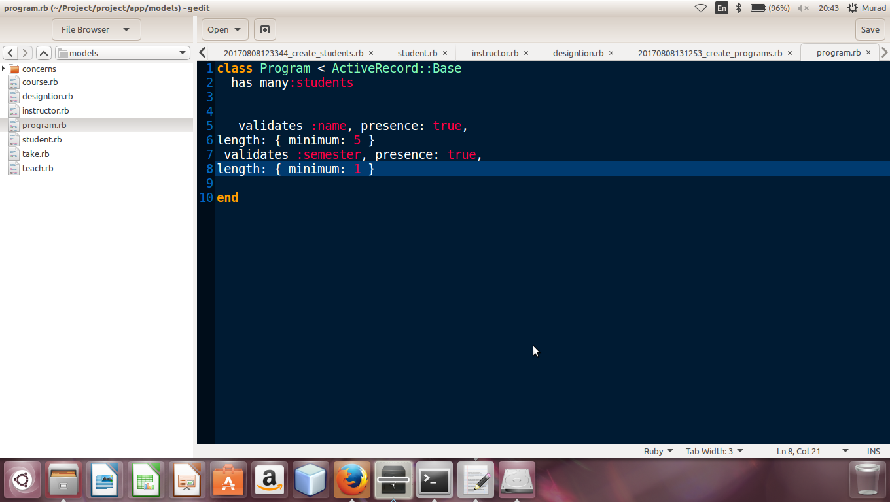

**Now Program**

As we discussed about new.html.erb form above which show in browzer like this while entering new program

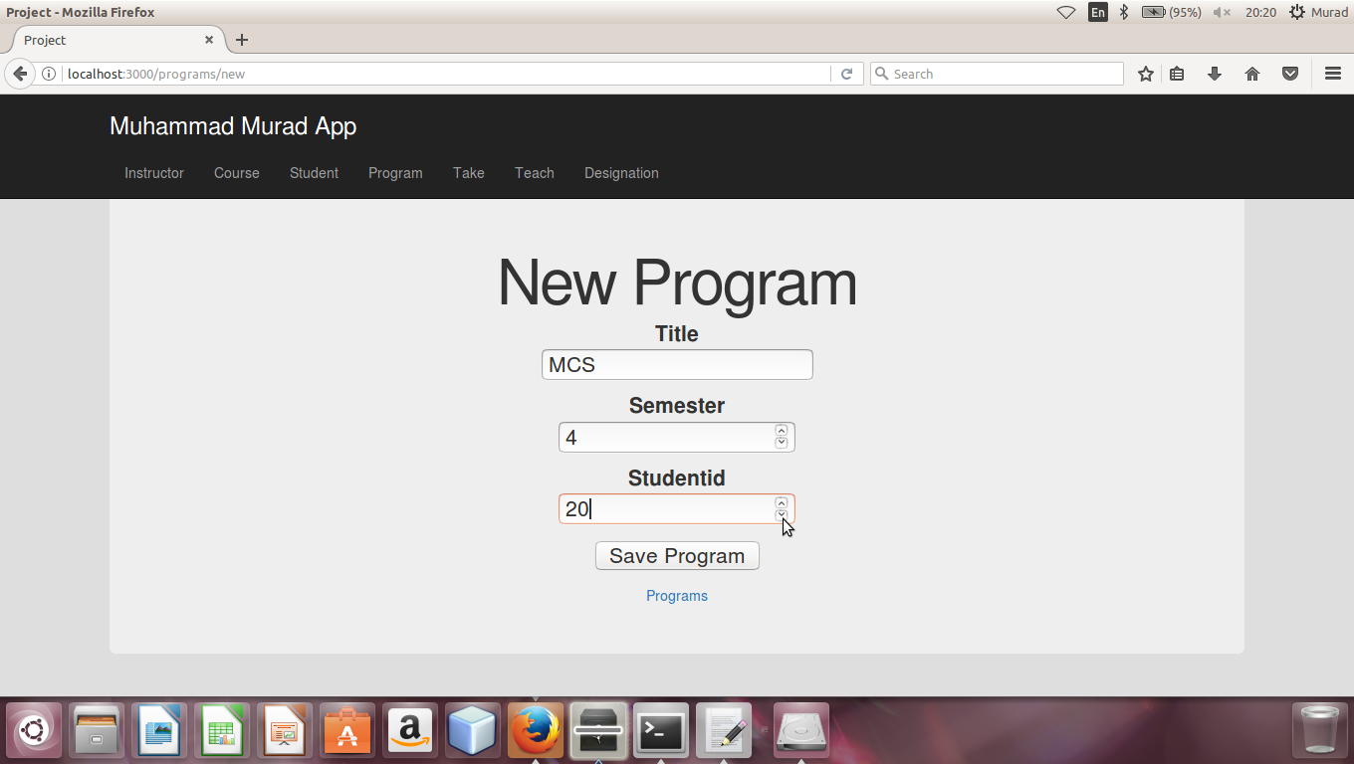

**Show Now program**

When we entered data in form and click on “Save Program” then new program will be shown like this

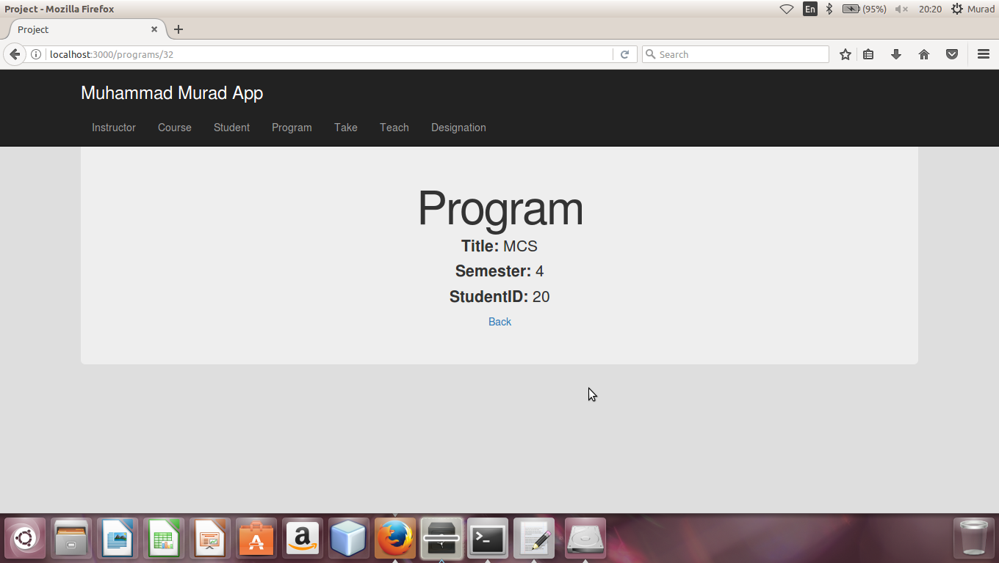

**List Of All Program**

Index.html.erb in view contain listing of all programs and the list of programs in browser shown like this. As you can see blow there is also option for delete show and edit in a list

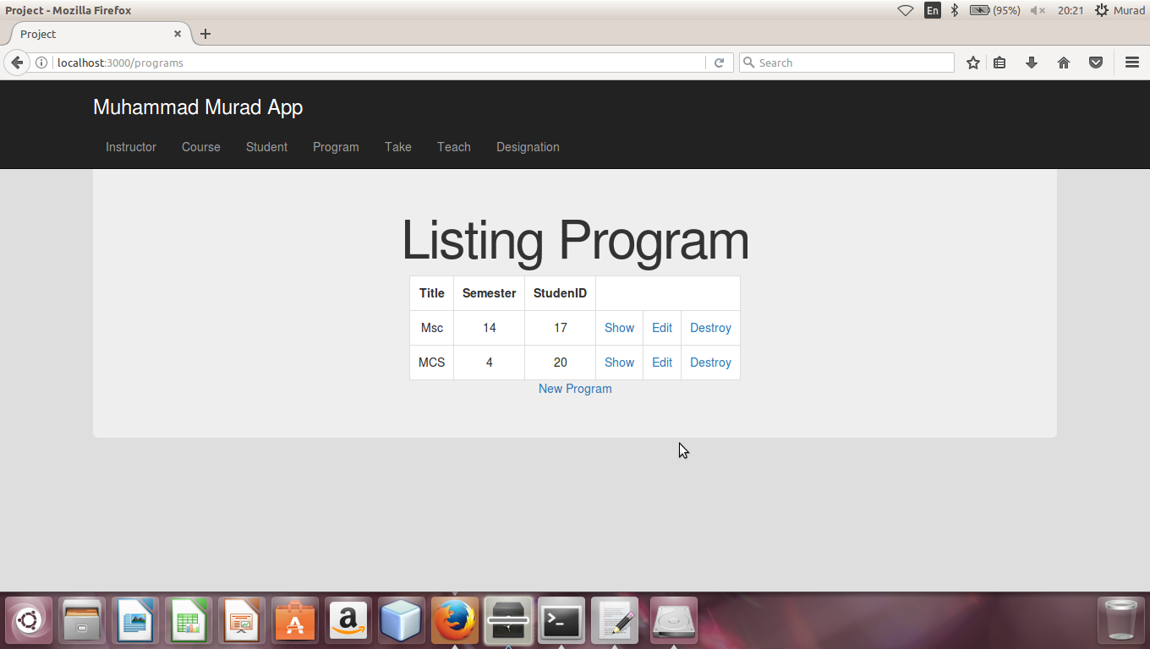

**Generation of Designation controller**

I have generated the designation Controller in Ruby on Rails and we defined all actions of designation likes save the designation index, delete ,edit ,show and update in controller and controller control all these kinds of action as shown in blow figure

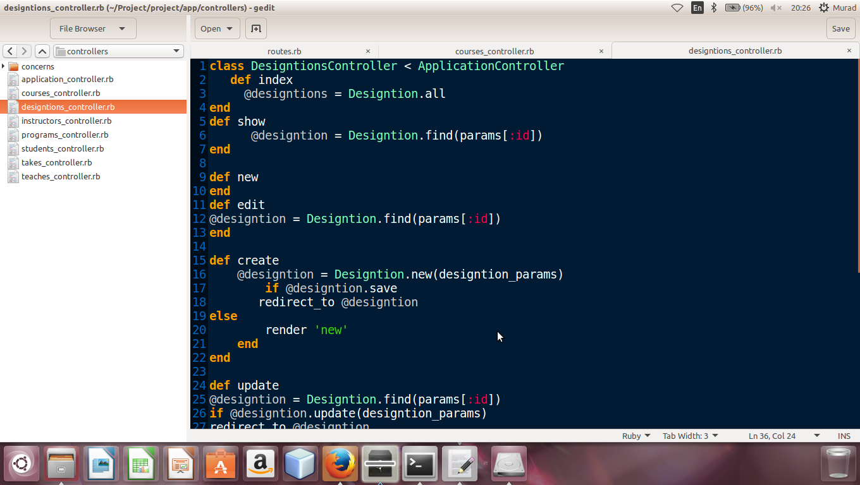

**Generation of Designation model**

This is Migration file of program because we have generated the model of designation and then we created and migrated its database in ruby on rails. The all attributes of designation model which we gave with the particular data type while generating designation model is also shown in migration file of designation

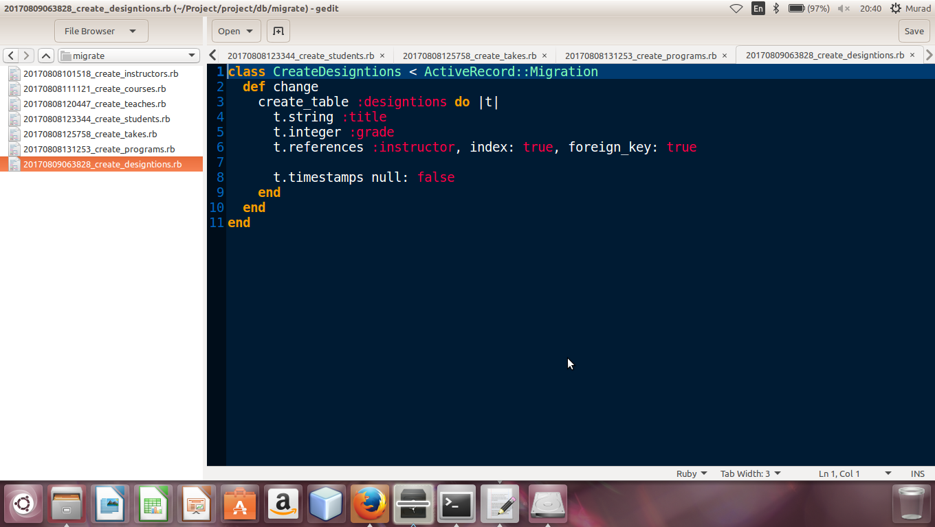

**View of Designation model**

View folder contain the following files which are new.html.erb, show.html.erb, edit.html.erb, index.html.erb ,all files are view file for user hand and action are define for these inside controller. the following files are

**now.html.erb**

it contain a form by this we make now entry for designation

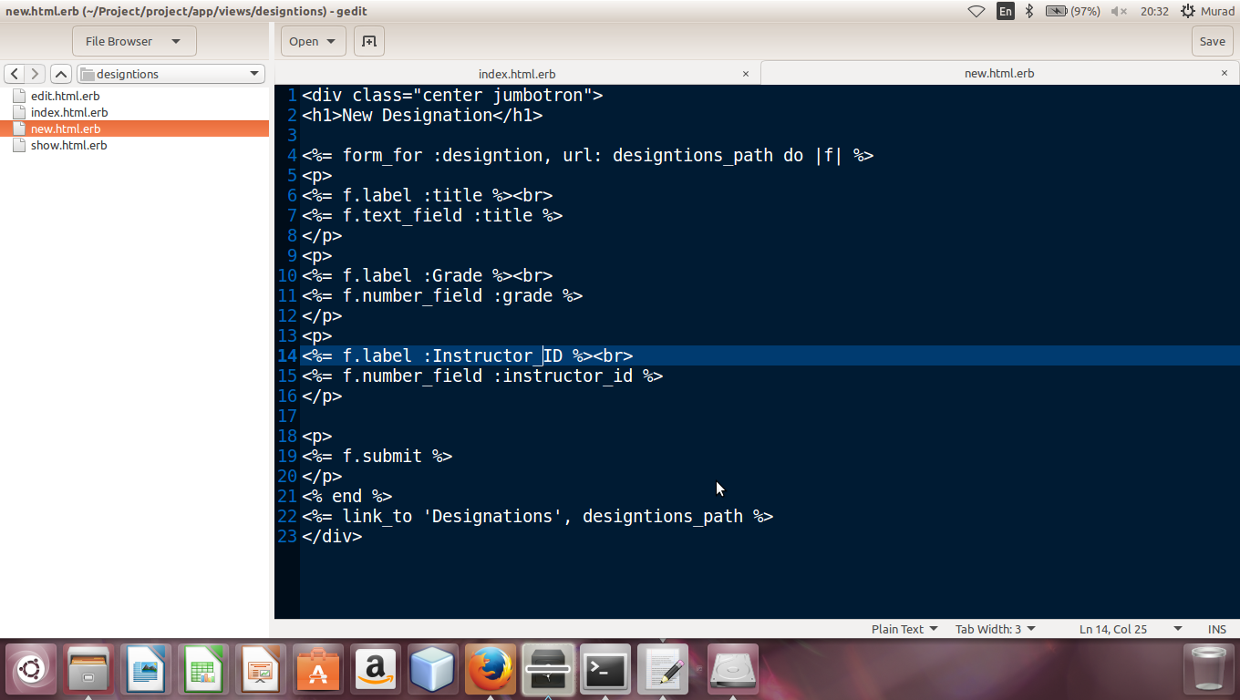

**show.html.erb**

When we put a some in a form of designation and click on save then show page shows a now enterd designation only

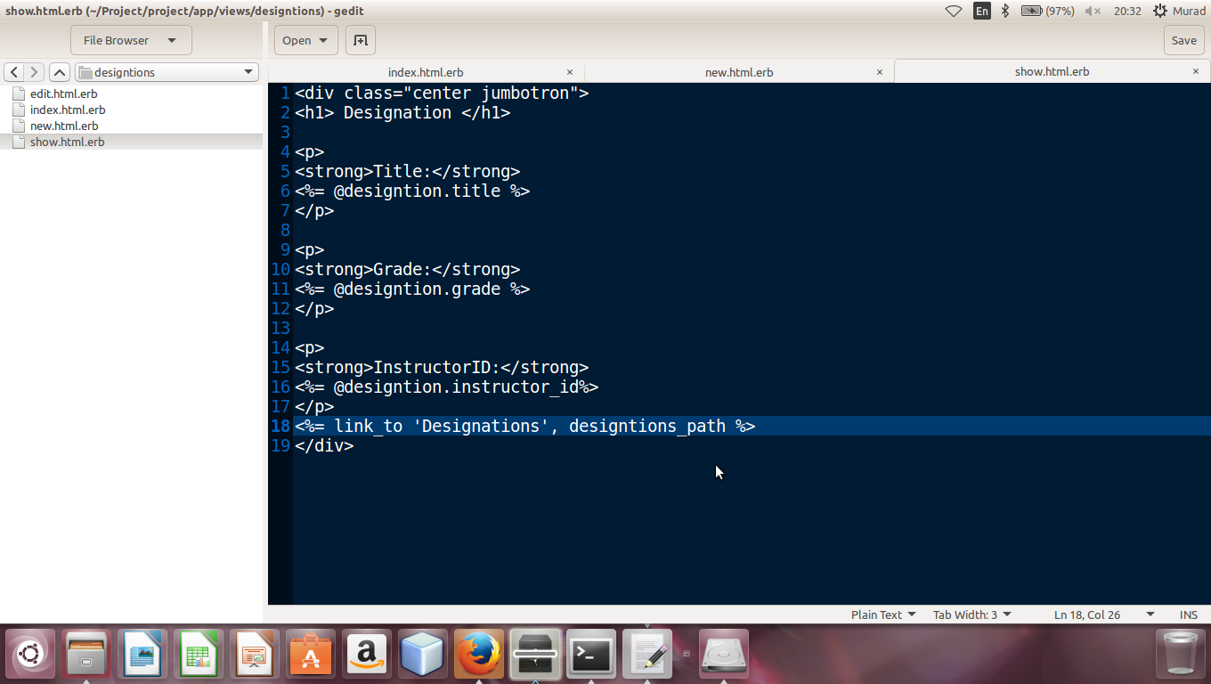

**Index.html.erb**

It contain list of designation which we entered all designation are shown in a listing order . it also contain delete ,show and edit option in front of each designation data

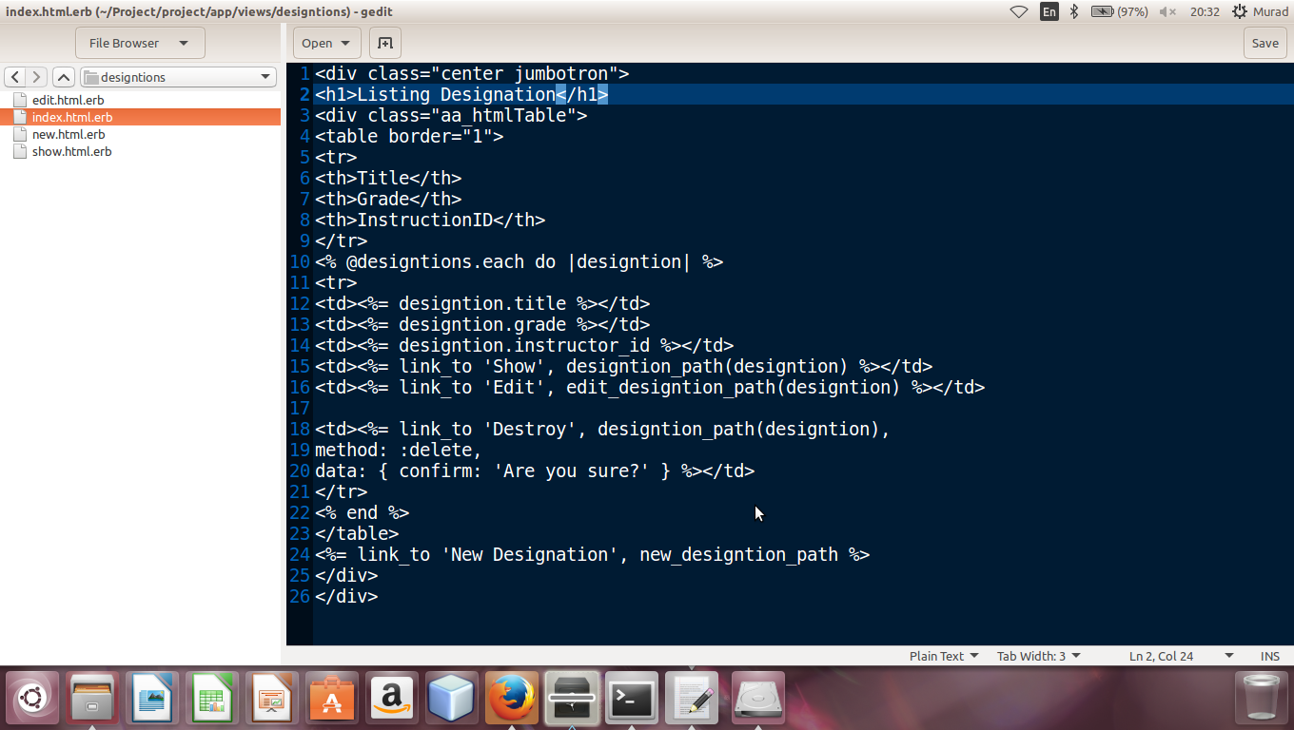

**Model of Designation**

In model of designation I showed association of designation model with others model like instructor model .Validation on fileds of designation table are also set.

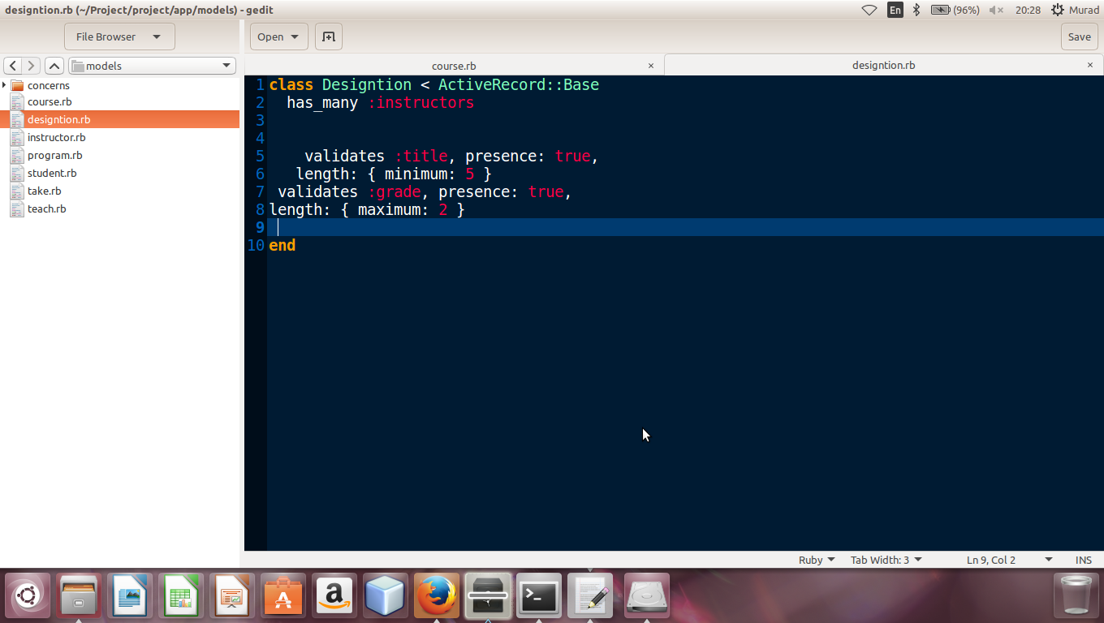

**Now Designation:**

As we discussed about new.html.erb form above which show in browzer like this while entering new designation

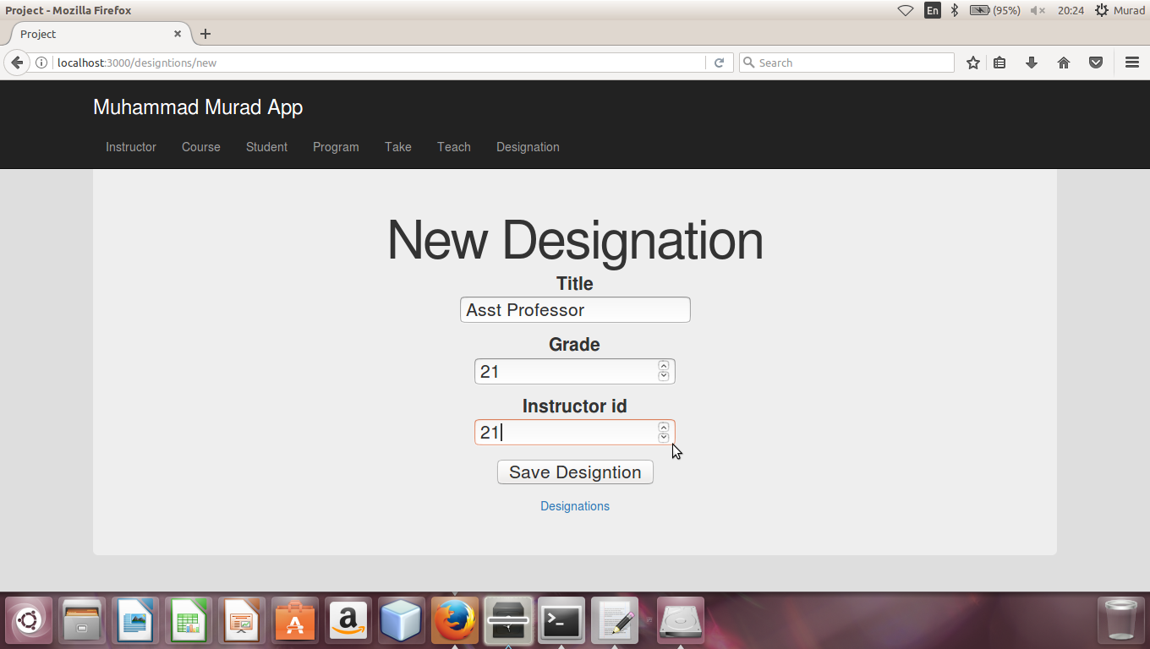

**Show New Designation**

When we entered data in form and click on “Save Designation” then new designation will be shown like this.

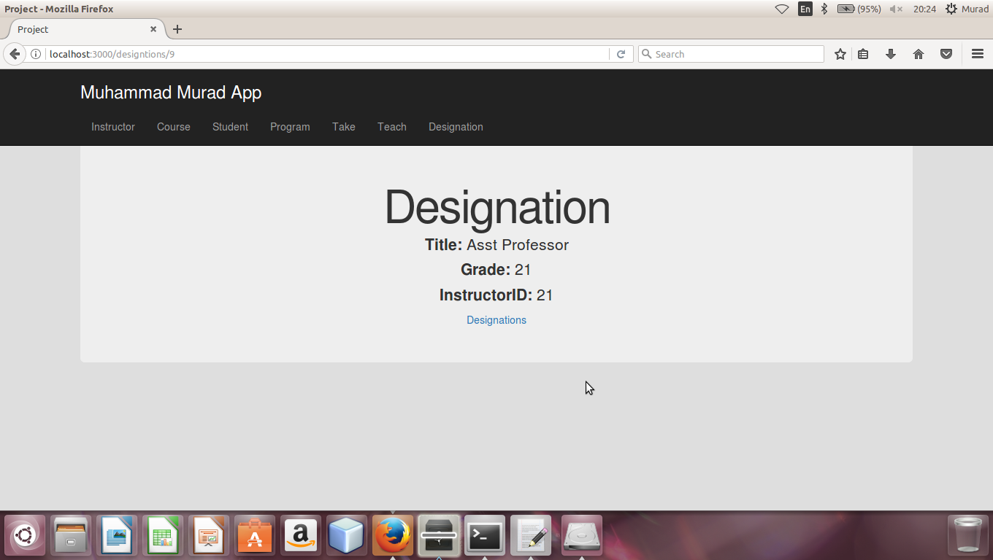

**List Of All Designation**

Index.html.erb in view contain listing of all designations and the list of designations in browser shown like this. As you can see blow there is also option for delete , show and edit in a list

